Commonwealth Newsletter    January 2026  Commonwealth United Methodist Church  2434 Commonwealth Ave. Charlotte, NC 28205 704-376-4924  www.commonwealthumc.org  Rev. Pilar Pérez - 704-995-1471 localpumc@gmail.com  Follow us on Facebook!  @CommonwealthUMC | From the Pastor’s Desk   Stepping Forward in Faith  As we begin January 2026, we step into a new year with gratitude for where God has brought us and hope for where God is leading us. A new year is an invitation to renew our faith, deepen our trust, and walk forward together.  Scripture reminds us, “See, I am doing a new thing” (Isaiah 43:19). While challenges remain, God is at work among us, calling us to faithfulness in prayer, worship, and love for our neighbors.  We move into this year not knowing everything that lies ahead, but trusting the One who holds our future. May 2026 be a year of renewed faith, shared hope, and faithful living as we continue to serve God together.  Rev. Pilar Pérez |   Reina Salinas, Carol Lowder, Bob and Jackie Samuels, Nadine Starnes, Greg (friend of AA)  If you know someone that needs to be added or removed, please let the church office know.    15th Newsletter Deadline  Please send anything you would like in the newsletter to the church office at  commonwealthumc@bellsouth.net  before January 15  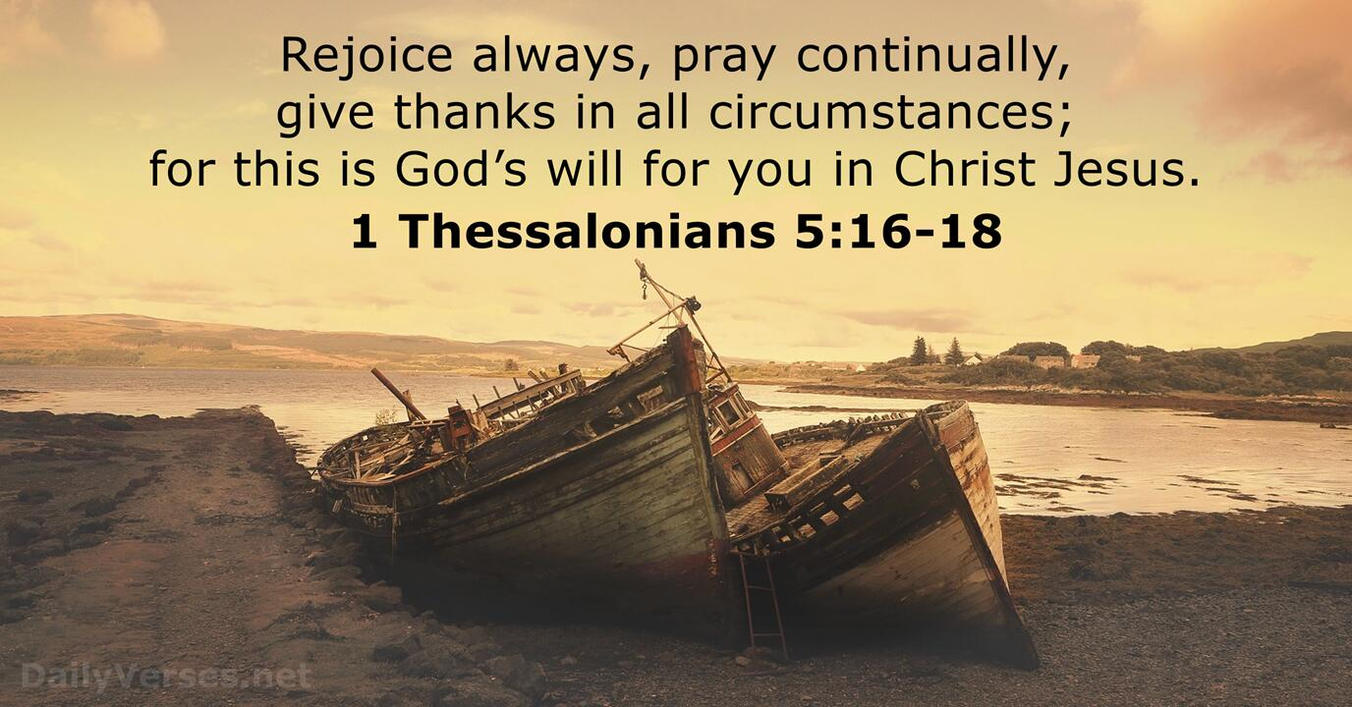



Memorials

For Billie Gardener:
By:
- Alice Shepherd
- Curtis & Susan Blount

January
7 Leigh Beaver
8 Jack Parrish
18 Reina Salinas
  - February
12 Rachel Brinkhoff
21Grace Beaver


Steward: Adriane Beaver
Usher: Reina Salinas
January 2026

Stewardship and Attendance
December 7, 2025

Offering - $396

December 14, 2025
Attendance - 20
Offering – $2,041

December 21, 2025
Attendance – 25
Offering - $5114.70

December 28, 2025
Attendance – 21
Offering - $5,222

Clothing Closet
10am-1pm
Saturday November 8, 2025
The Clothing Closet is FREE and open to
anyone and everyone!
Spread the word to anyone who has a need!
clothing
Donations needed!

