Pastor’s Walk

I was born in Dallas, Texas in what my kids lovingly call the dark ages. Back in the late 60’s and early 70’s it was a great place to be a kid…at least it was for me. We had a great low slung 1960’s house in a neighborhood with lots of other kids to play with and not more than five blocks from my school. Which meant I could walk or ride my bike to school every school day. And in the era of bussing, that was a big deal. I will tell you I have several fond childhood memories from my hometown.

My fondest is of the drive-in theater. Yes, I am just old enough to remember drive-in theaters, barely, and the joy of loading up the car with blankets and pillows and a big Tupperware tub of fresh popped popcorn with real butter on it and heading off to the drive-in for a late night of fun and maybe a movie or two. We had a 1972 green Buick Skylark with the perfect hood for cuddling up on and watching movies…I miss the days when you could sit on the hood of a car and not worry about denting the thing.

It was at this drive-in I watched with my family “Young Frankenstein” (I am sure asking, “If this isn’t an old movie why is it in black and white?”), “Herbie the Love Bug” and, of course, “Star Wars” which had me running around for the next six months pretending to fire a laser gun…Joo..Joo…JUoooo.

The best thing about the drive-in we went to back then was its location. You see that drive-in theater was situated in the parking lots of the Dallas Cowboys football stadium right in the shadow of the infamous dome with a hole in it. It was like watching a movie next to a holy shrine for many of us there in Dallas. And we all loved it!

And the very best thing about…well any drive in…even ones not in the shadow of the Dallas Cowboy stadium is that you drive, into the movie theater, your own personal space that is all yours…and you take it home with you after the movie is over. Watching a movie in the comfort of your own vehicle was the best…no sticky floors…no body kicking the back of your seat (except your little sister)…and if you had a 1972 Buick Skylark a hood that went on for days.

And it is this aspect of the drive-in that I think we can utilize for a church service currently during the COVID-19 pandemic…minus the big green hood. Some of you have already probably guessed where I am going with this…drive-in worship.

I am not all that sure when we will be allowed to have indoor worship and even when we are allowed to have indoor worship again just how long it will last until the Flu season hits and we find that the Flu combined with COVID means we need to pause indoor worship again. This being said, it seems to be that as the temperatures are now starting to inch away from boiling and returning to more suitable temperatures for outside activities it would be a good time for us at Commonwealth to develop a drive-in church worship service.

I am in the process of obtaining the necessary equipment to broadcast such a service via FM radio waves which will mean all folks will need to do is pull up into our parking lot…park their cars in a space and tune their radios to the appropriate unused FM radio frequency to hear the service and see it through their windshields.

No…it will not be just like the services we could have indoors. Just as a drive-in theater is nothing like watching a movie in an indoor movie theater. However, it will allow us to gather in the safety of our own vehicles and pray together and hear worshipful music and a short message. We may even be able to incorporate Holy Communion into the plan with enough practice.

Right now, my plan is to begin Drive-in worship services starting September 6th with the service beginning at 10:30 am (since it is still getting hot out there some days). The service will last about thirty minutes. After the service, it will be just like a drive-in movie theater. Everyone will start up their vehicles and slowly make their way to the exit. The church building will be locked so there will be no need to disinfect anything and since everyone stays in their vehicles contact will be limited to best protect one another and those who are most vulnerable to this virus.

More information will be coming out as we get closer to the 6th but just wanted to let everyone know so ya’ll could mark your calendars.

Grace,
Rev. Steve Kurt

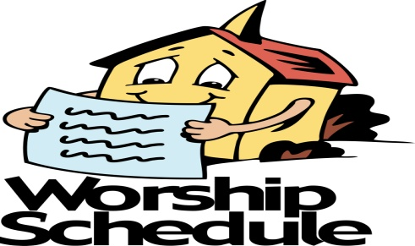

All Church activities have been postponed
until further notice.
Also, the Fellowship remains closed.

Just to be clear, the Church has not been closed, so it does not need to be re-opened. We have simply stopped worshipping in our buildings for a time to protect the health and well-being of our people and our communities. The Church does not require a building in order to be the Church. What is required is love, compassion and the presence of God.

Church Monthly calendar

With church being closed and all church activities being canceled until further notice, there is nothing to add to the church calendar at this time. We have decided to suspend printing the monthly calendars and will start again when the church activities resume. Sorry for any inconvenience or confusion this may cause individuals.

Fellowship Hall Update

As many of you know, on July 4th the cities sewer line broke and backed-up raw sewage into Fellowship Hall. The sewage was quickly cleaned-up and the space was disinfected but there is still some work to be done on the walls and baseboards due to water damage. Over the past couple months, this work has been going very slowly. It is not the work that is going slowly as much as the decision process for what to do is going painfully slowly. The problem stems from asbestos dust being found in the air conditioning duct work and how-to best deal with it and who is going to pay for it.

It is believed the dust came from the last time there was a sewage back-up in Fellowship Hall and the floor tiles were replaced which had asbestos in them and in the mastic to glue them down. Essentially, the job of asbestos abatement was either not done correctly or not done at all. This has required a great deal of digging into our records and finding receipts and such to give to the insurance company. Right now, the insurance company is investigating the issue and working with the previous abatement company to see if an acceptable resolution can be achieved. This, unfortunately, is taking some time.

There are several questions swirling around this issue right now and the truth is that no one knows how this is all going to work out. The truth is our church could be hit with a huge repair bill….or the insurance company could pick-up the tab….or we could be forced to seek legal representation in a suit against the previous abatement company…or a combination of all these possibilities plus a few more twists just to make it even more frustrating.

The bottom line for right now is this…Fellowship Hall is closed completely to all until further notice.
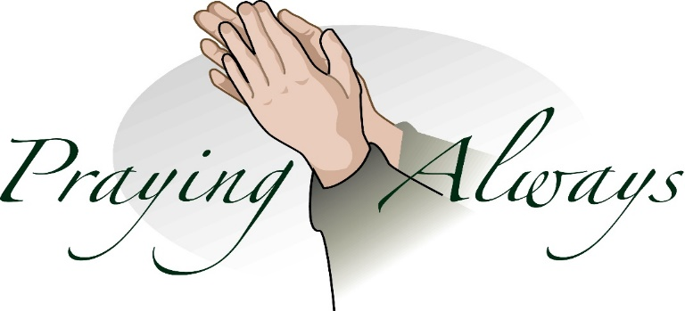

Wednesday is Day of Prayer
Remember to pray for those in need.
Prayer box located in the Narthex

Our Prayer List

Ruby Agnew, Jack Harwell (brother of Ruby Agnew), Alma Horne, Pat Inman (sister of Jackie Samuels), Maxine Kincaid, Rosemary Lands, Martha Lee,Jean Stoneman

Sympathy

The Commonwealth Church Family would like to express its sympathy to John Beaver and his family on the passing of John’s brother William Beaver who passed away July 31, 2020.
May God comfort them in this time of grief and sorrow.

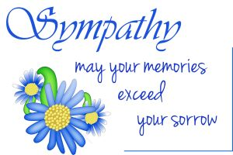

Congratulations

The Commonwealth Church Family would like to congratulate Rebecca Kurt and Olivia Biro who were married on Saturday, August 8, 2020.

May God continue to bless their marriage with love, joy and happiness.

September Birthdays

2 Walter Rich, Jr.
16 Peggy Bridgers
18 Kay Little
27 Elise McMillion
September Anniversaries

8 Nancy and John McNamara
12 Shirley and Leonard Laye
15 Sherry and Chris Ruane

On the Funnier Side of Things

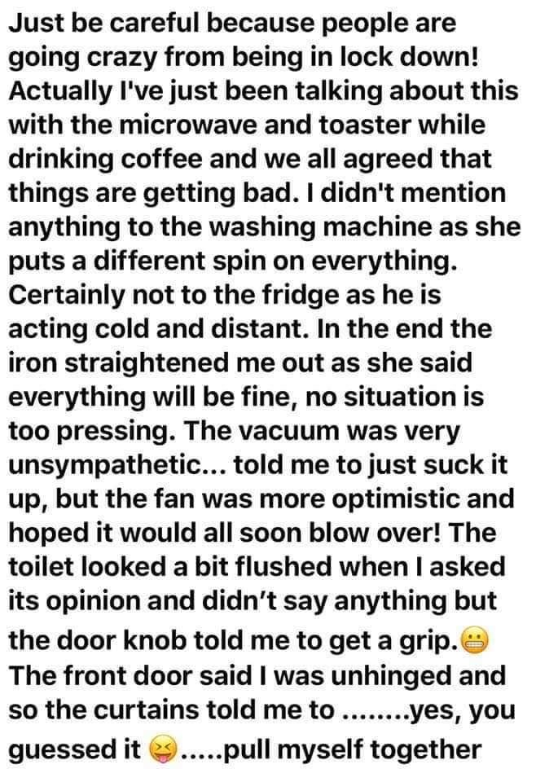

September 7th

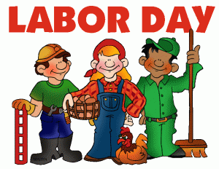

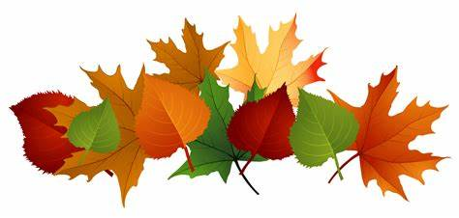

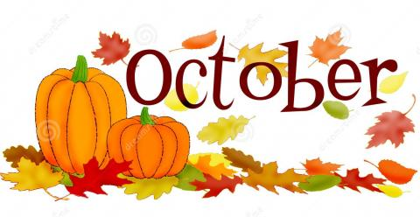

October 31st

Halloween

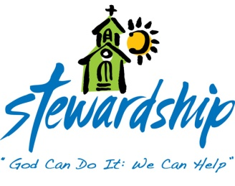

July 26, 2020
Church canceled
Offering -$240.00

August 2, 2020
Church canceled
Offering - $0.00

August 9, 2020
Church canceled
Offering -$2,225.00

August16, 2020
Church canceled
Offering -$1,250.00

August 23, 2020
Church canceled
Offering -N/A

Commonwealth
United Methodist Church
2434 Commonwealth Ave.
Charlotte, NC 28205-5132
704-376-4924

August 25, 2020

Steve Kurt - Pastor
Patience Brumley - Pastoral Care

