**Pastor’s Walk**

Blessings,

I hope you all are continuing to do well and staying safe. It has been a long and strange summer and the fall is shaping-up to be one filled with challenges and questions all its own. Today, I want to address some of those challenges and questions specifically in terms of our church.

**First**, this past month we started having in-person worship and it has gone well. We have managed to stay within the 25-person limit and set the sanctuary up to keep folks a good distance apart. We have also been broadcasting the service out into the parking lot via the FM radio waves. And, of course, we have continued to have the message put out on YouTube each week. Taken all together, we have well over 30 to 40 people worshiping with us every week. For a church our size, I think we are doing an excellent job of reaching out to as many folks as we can with our Sunday messages.

So, the question begs to be asked…how much longer are we going to have to engage in this modified kind of worship with so many moving parts and with so many restrictions? And the short answer is…I do not know? I do know that it is looking like we will have heavily restricted in-person worship well into the Advent season and possibly beyond. The reason for all the uncertainty is because no one knows how all this COVID stuff is going to play out as we move into cold and flu season. To be honest, at CUMC, we are going to take the approach of slow and steady. We are going to move forward with an abundance of caution and, if necessary, we will pause our forward motion or even possibly take a step or two backwards. The important thing is that we remain flexible and willing to be patient.

**Second**, when will we be able to sing at church and have church luncheons again. Again, the short answer is I do not know for sure when these activities will be allowed, however, indications are that it will be way into next year before we can begin these activities again. That could all change…but I am doubtful. At any rate, as far as luncheons go, until Fellowship Hall is cleaned-up and ready we are a church without a space to hold luncheons.

**Thirdly**, what is going on with Fellowship Hall. The answer is…we are in an insurance standstill right now as testing is being conducted and insurance folks are having discussions and making decisions. The long and the short of it is…until they decide how they want to move forward; we cannot decide how we are going to move forward.

**Finally**, with all these questions and challenges and such, how are we going to celebrate Advent and Christmas at CUMC this year. The answer is…like Lent and Easter this year, Advent and Christmas may have a vastly different feal to it. Those traditions that we have regularly engaged in at CUMC may have to be modified or completely changed this year. We may even have to forgo some (like our Christmas Luncheon). The truth is we have spent most of this entire year having to modify our plans and forgo things and that truth is going to continue for the remainder of this year.

The thing is, this can either be a huge loss or a giant gain for us…and it all depends on how we look at the situation. If all we do is lament that which we have lost and focus on that which we cannot do…it will be a loss. However, if we go into this Advent and Christmas season grateful for all that God has provided and continues to provide with a mindset of knowing that this too shall pass and very soon we will be able to once again do those things which have become tradition, we may find that we are being presented with some awesome opportunities. Perhaps, we can find new meaning in this time of year as we are all forced to slow down and engage in life in a much more pared down way. Maybe, instead of trying to fit everything in that this time of year seems to encourage us to do…we may find that we finally have the chance to only do those things with the most meaning and realize the rest did not feed us as much as it drained us.

The goal for the remainder of this year should not be to get back to normal as quickly as possible…. that could be dangerous and quite frankly reckless. However, maybe our goal can be to take these challenges and changes as opportunities to adjust our lives so that we are in better tune with what God would have us to do…the people God would have us to serve…the traditions and activities that better help us to become closer to God (rather than something we do just because we have always done them).

Personally, I am looking at this all as an opportunity to reset my priorities and go forward into a new year with an eye towards what God would have me to do in my ministry and my life.

And that is a good thing…in a regular year or in a pandemic year!

Grace,

Rev. Steve Kurt

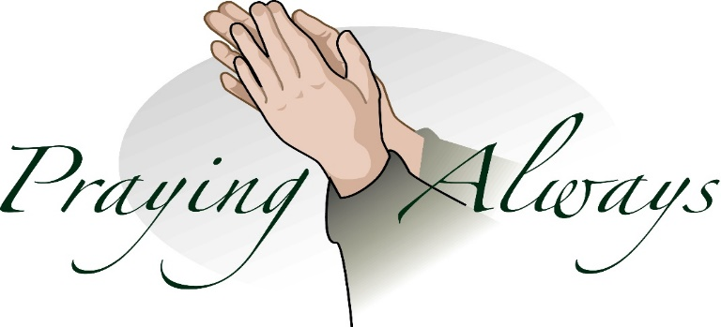

***Church Monthly calendar:***

With church being closed and all church activities being canceled until further notice, there is nothing to add to the church calendar at this time. We have decided to suspend printing the monthly calendars and will start again when the church activities resume. Sorry for any inconvenience or confusion this may cause individuals.

***Charge Conference:***

*Will be held on November 15that 12:30 pm (following worship) in the Sanctuary.*

*The presiding Elder will be Amelia Stinson-Wesley from Memorial UMC.*

***Fellowship Hall:***

*Until further notice, Fellowship Hall will remain closed to all church activities and outside group meetings until the we can resolve the asbestos issues.*

***In- person Worship time change:***

*We will continue to have in-person worship for the month of October. The new times for this worship service will be from 11:00 to 11:30 am. We will also continue to broadcast this service to the lower parking lot via the FM radio. You can also find our Sunday message on YouTube at my channel Pastor Steve Kurt.*

Grace,

Rev. Steve Kurt

Commonwealth UMC

**Wednesday is Day of Prayer**

Remember to pray for those in need.

Prayer box located in the Narthex



**Our Prayer List**

Jack Harwell (brother of Ruby Agnew), Alma Horne, Pat Inman (sister of Jackie Samuels), Maxine Kincaid, Rosemary Lands, Martha Lee,Rick Morrison, Jean Stoneman



**October Birthdays**

5 Charles Stephenson

11 Joyce Yates

12 Danny Haigler

15 Marilyn Melton

15 Pia Roe

16 Courtney Maggio

25 Connie Boza

28 Adriane Beaver

28 Steve Kurt

30 Rebecca Kurt



**October Anniversaries**

12 Dawn and Perry Beaver

**The Autumn of Life**

By Helen Steiner Rice

What a wonderful time is life’s autumn,

When the leaves of the trees are all gold,

When God fills each day as He sends

it with memories, priceless and old.

What a treasure-house filled with rare jewels are the blessings of year upon year,

When life has bene lived as you’ve lived it

in a home where God’s presence is near…

May the deep meaning surrounding this day, like the paintbrush of God up above,

Touch your life with wonderful blessings,

And fill your heart brimful with His Love.



**Church cleanup**

Scheduled for Saturday, Oct. 17 at 9:00 for our groundsclean-up day to:

1. Clean out the butterfly garden and get it ready for winter.
2. Trim hedges/bushes around the church.
3. Put out pine needles or something similar around the bushes.
4. And anythingelse we see that needs attending to.

I will bring thebags and, hopefully, the pine needles.

Thanks to all.

Phyllis

704-517-2301







**12th*Columbus Day***

**C:\Users\Owner\AppData\Local\Microsoft\Windows\Temporary Internet Files\Content.IE5\GWZ1PHLX\MC900051019[1].wmf**

**31st*Halloween***



Saturday Night (Oct/31) - Remember turn your clocks ***BackOne Hour*** before going to sleep



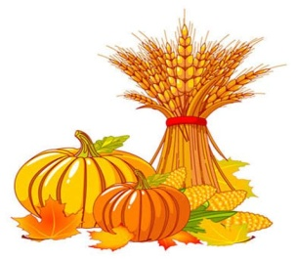



**1st*Daylight Saving Time Ends***

**11th*Veterans Day***

C:\Users\Owner\AppData\Local\Microsoft\Windows\Temporary Internet Files\Content.IE5\GWZ1PHLX\MC900104344[1].wmf

**26th*Thanksgiving***



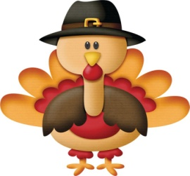

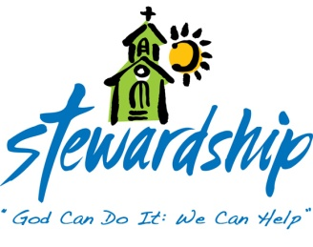

**August 30, 2020**

Church canceled

Offering –$3,445.00

**September6, 2020**

Church (Drive-in / 15 cars)

Offering - $2,290.00

**September 13, 2020**

Church

Offering -$660.00

**September 20, 2020**

Church

Offering -$1,320.00

**September 27, 2020**

Church

Offering -$610.00

Commonwealth

United Methodist Church

2434 Commonwealth Ave.

Charlotte, NC 28205-5132

704-376-4924

September 29, 2020

*Steve Kurt* - Pastor

*Patience Brumley* - Pastoral Care