**Pastor’s Walk**

Recently, I have had the opportunity to meet with and talk with (if only virtually) several other UMC pastors in our area. It was good to reconnect after a very long and arduous summer. It was also good to have the opportunity to encourage one another in what is continuing to be a very difficult time to “do” ministry.

Here are some reflections from my conversations with other UMC pastors:

1. The challenges of this pandemic have been felt far and wide and no matter the amount of planning or financial resources churches have had on hand has diminished its impact on folks. I have talked with pastors from small churches to large mega-type churches and their ministries are all struggling to stay connected and effective.
2. The number one concern of all the pastors I have spoken with has been around the issue of “connection.” Many of us feel like we have lost our connection…not only to our congregations but to our communities. I have heard idea after innovative idea shared in our talks. I mean, churches are pulling out all the stops when it comes to trying to connect with folks virtually and through phone calls and letters and newsletters and…you name it a church out there has tried it. When the question is then asked…” So, how effective were your efforts?” Time and time the answers have been “So, so” or “It started off great but as the weeks and months have worn on, we are losing people.” Keeping folks connected with each other and the church is just such a challenge when life seems to be going sideways everywhere else!
3. One last thing I have been hearing…folks are starting to get burned out. I think it is safe to say that none of us ever expected to be dealing with all this COVID stuff for so long…and it is looking like we are not done yet. Many of us are tired and frustrated and worn out and just ready for it all to end. Then you pour the unrest that seems to be running rampant in our country right now…can we just admit…it is a little much.

My point is…we are in unprecedented times and I think all of us are just trying to figure out what to do next…including those of us leading the church both lay and clergy alike. There are just so many questions out there and we have so few answers.

And this brings me to a very important point. Doing church right now is difficult and challenging and very unsure for all of us…not just for pastors. We are all struggling to grow and be the church. Things are tough…and the last thing we need to do is make things harder than they already are for ourselves.

Yet…I have been hearing some very disturbing reports from within our own Commonwealth congregation. Reports of rumors being spread about what is going to happen to Commonwealth and to the choir and to our worship service. Rumors that are grossly untrue and ones I am sure are fueled by fear and misinformation. Rumors that are upsetting to hear and are destructive and…Let me state this very clearly…Untrue!

I believe that Jesus went to the cross for us all so that we could live not in the darkness of rumor but in the light of grace and forgiveness and truth. And here is some truth, Commonwealth will continue into next year just as we have continued into every year since its inceptions…. depending heavily on the power and help of the Holy Spirit. Will things be different at Commonwealth…yes…they must be with this pandemic. Will certain traditions need to be altered or completely abandoned…yes but we will replace them with new traditions that are safer and more appropriate in the light of a virus that has killed over 200,000 Americans. Will Commonwealth continue to seek out opportunities to utilize one of our most valuable commodities…our space…yes, we will continue to seek out rental partners. Will Commonwealth continue to seek out chances to be in partnership with other communities of faith…yes…pandemic or not we are called to be one church.

As we hopefully begin the long process of emerging from the challenges of 2020, let us do so with grace and love and trust in the One whom we have always been able to trust completely. Let us rely even more heavily on the Holy Spirit and let us walk not in fear but in the footsteps of Christ Jesus as we love each other and accept one another in the same grace and spirit as Christ accepts and loves us.

Grace,

Rev. Steve Kurt

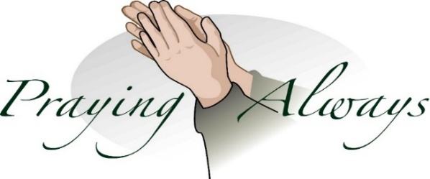

***Church Monthly calendar:***

With church being closed and all church activities being canceled until further notice, there is nothing to add to the church calendar at this time. We have decided to suspend printing the monthly calendars and will start again when the church activities resume. Sorry for any inconvenience or confusion this may cause individuals.

***Charge Conference***



*Will be held on November 15that 12:30 pm (following worship) in the Sanctuary.*

*The presiding Elder will be Amelia Stinson-Wesley from Memorial UMC.*

***Administrative Council Meeting***

Sunday November 22nd (following worship) in the Lands Class.

***Fellowship Hall:***

*Until further notice, Fellowship Hall will remain closed to all church activities and outside group meetings until the we can resolve the asbestos issues.*

**Our Sympathy**

**The Commonwealth church family would like to express its sympathy to the family of Victor Mayenge who passed away on Wednesday, September 23, 2020. May God comfort them in this time of grief and sorrow.**

**Wednesday is Day of Prayer**

Remember to pray for those in need.

Prayer box located in the Narthex



**Our Prayer List**

Pat & David Hampton (friends of Margieand Ron), Jack Harwell (brother of Ruby Agnew),Bob &Nancy Hoy(brother &sister-in-law of Margie)Alma Horne, Pat Inman (sister of Jackie Samuels), Maxine Kincaid, Rosemary Lands, Martha Lee,Rick Morrison, Carol Painter, Donna Pruitt, Jean Stoneman

**Donna Pruittis inrehab at the VA hospital.** Her address is:Ms. Donna Pruitt

1601 Brenner Ave.

Building 42, 1D

Salisbury, N. C. 28144



**November Birthdays**

7 Elyse McMillion

10 Connie Lewis

12 Phyllis Batts

12 Samuel Ingold

13 Rosemary Lands

16 Ashley Ingold

21 Trish Borchert

24 Bob Samuels

24 Misty Scott

25 Vera O’Pry

28 Nancy Stacey

**Commonwealth Leadership Team**

**for the Coming Year**

Thank-you to everyone who said yes to the call to leadership for our church in the coming year…we have many who will be staying on at their post for 2021. We still have an opening for a position for Trustee. If you are interested, please let Rev. Steve Kurt know as soon as possible.

Those who volunteered for the Kitchen Committee will continue on that committee if they choose…Marie Rich will continue to head-up and recruit for that committee also.

Grace,

Rev. Steve Kurt

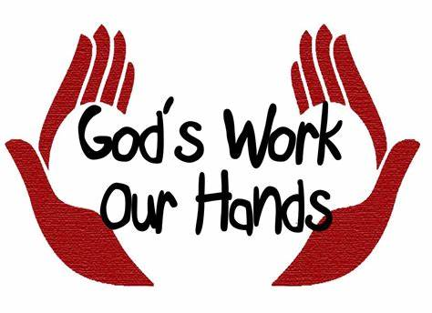

**Rick and Sue Morrison’s**

**address at the farm**

Rick Morrison’s doctors and medical treatments are out of UNC Hospitals. The treatments are at the Hillsborough Campus. We would like to support them in our thoughts and prayers during these times. They will be mostly at the farm during these times, so the farm address is:

6615 Walnut Grove Church Rd.

Hurdle Mills, NC 27541



***Administrative Council:***

*Chair: Perry Beaver*

*Trustees: Gene Hartsell*

*TBD*

*Finance: Alice Shepherd*

*Leigh Beaver*

*Worship: Adriane Beaver*

*SPRC Rep: Dawn Beaver*

*Mission/Outreach: Sandy Painter-Kurt*

*Nurture: Marie Rich*

*At-Large Member: Sandra Pearre*

*Youth Reps: Robert Kurt and  
Gracie Beaver*

*Lay Leader: Phyllis Batts*

*Annual Conference Rep: Phyllis Batts*

***Staff Parish Relations Committee:***

*Dawn Beaver*

*Phyllis Batts*

*Adriane Beaver*

***Kitchen:***

*Marie Rich*

*Billie Gardner*

*Phyllis Batts*

*Jackie Samuels*

***Church Historian:***

*Mary Pearre*

*Rosemary Lands*

***Youth and Children:***

*Dawn Beaver*

*Sandy Painter-Kurt*

**Christmas Poinsettias**

If you would like to purchase a Poinsettia to be placed in the Chancel area during the Advent/Christmas season “In Honor Of” or “In Memory Of” a loved one, please place your order and payment in an envelope marked “Poinsettias” and place it in the offering plate on Sunday morning. You may also mail it to the church office at 2434 Commonwealth Ave, Charlotte, NC 28205. Please make checks payable to Commonwealth UMC. The cost of each poinsettia is $9.00.

**Orders must be received by**

**10amon Monday, November 23, 2020**.

Number of poinsettias ordered ___________

Amount enclosed ______________________

In Memory Of:

____________________________________

In Honor Of: ____________________________________

Placed By: ____________________________________



**Lay Servant training**

The Metro District conducteda 10-hour Basic Lay ServantMinistry course this past weekend (October 3rd), which Phyllis Batts attended on Zoom.

On October 11, 2020The Metro District held a Lay Servant Commitment Service via Zoom. Over ninety lay servants, instructors, pastors, and family were present as they recognized and celebrated the work of the laity. Certificates will be mailed.



Congratulations, Phyllis❣️Thank you for doing this! You have shown such dedication to servant ministry in so many ways!

Blessings ~ Patience

**Stewardship Sunday**

**DateToBe Determined**

Think about your commitment to your church.



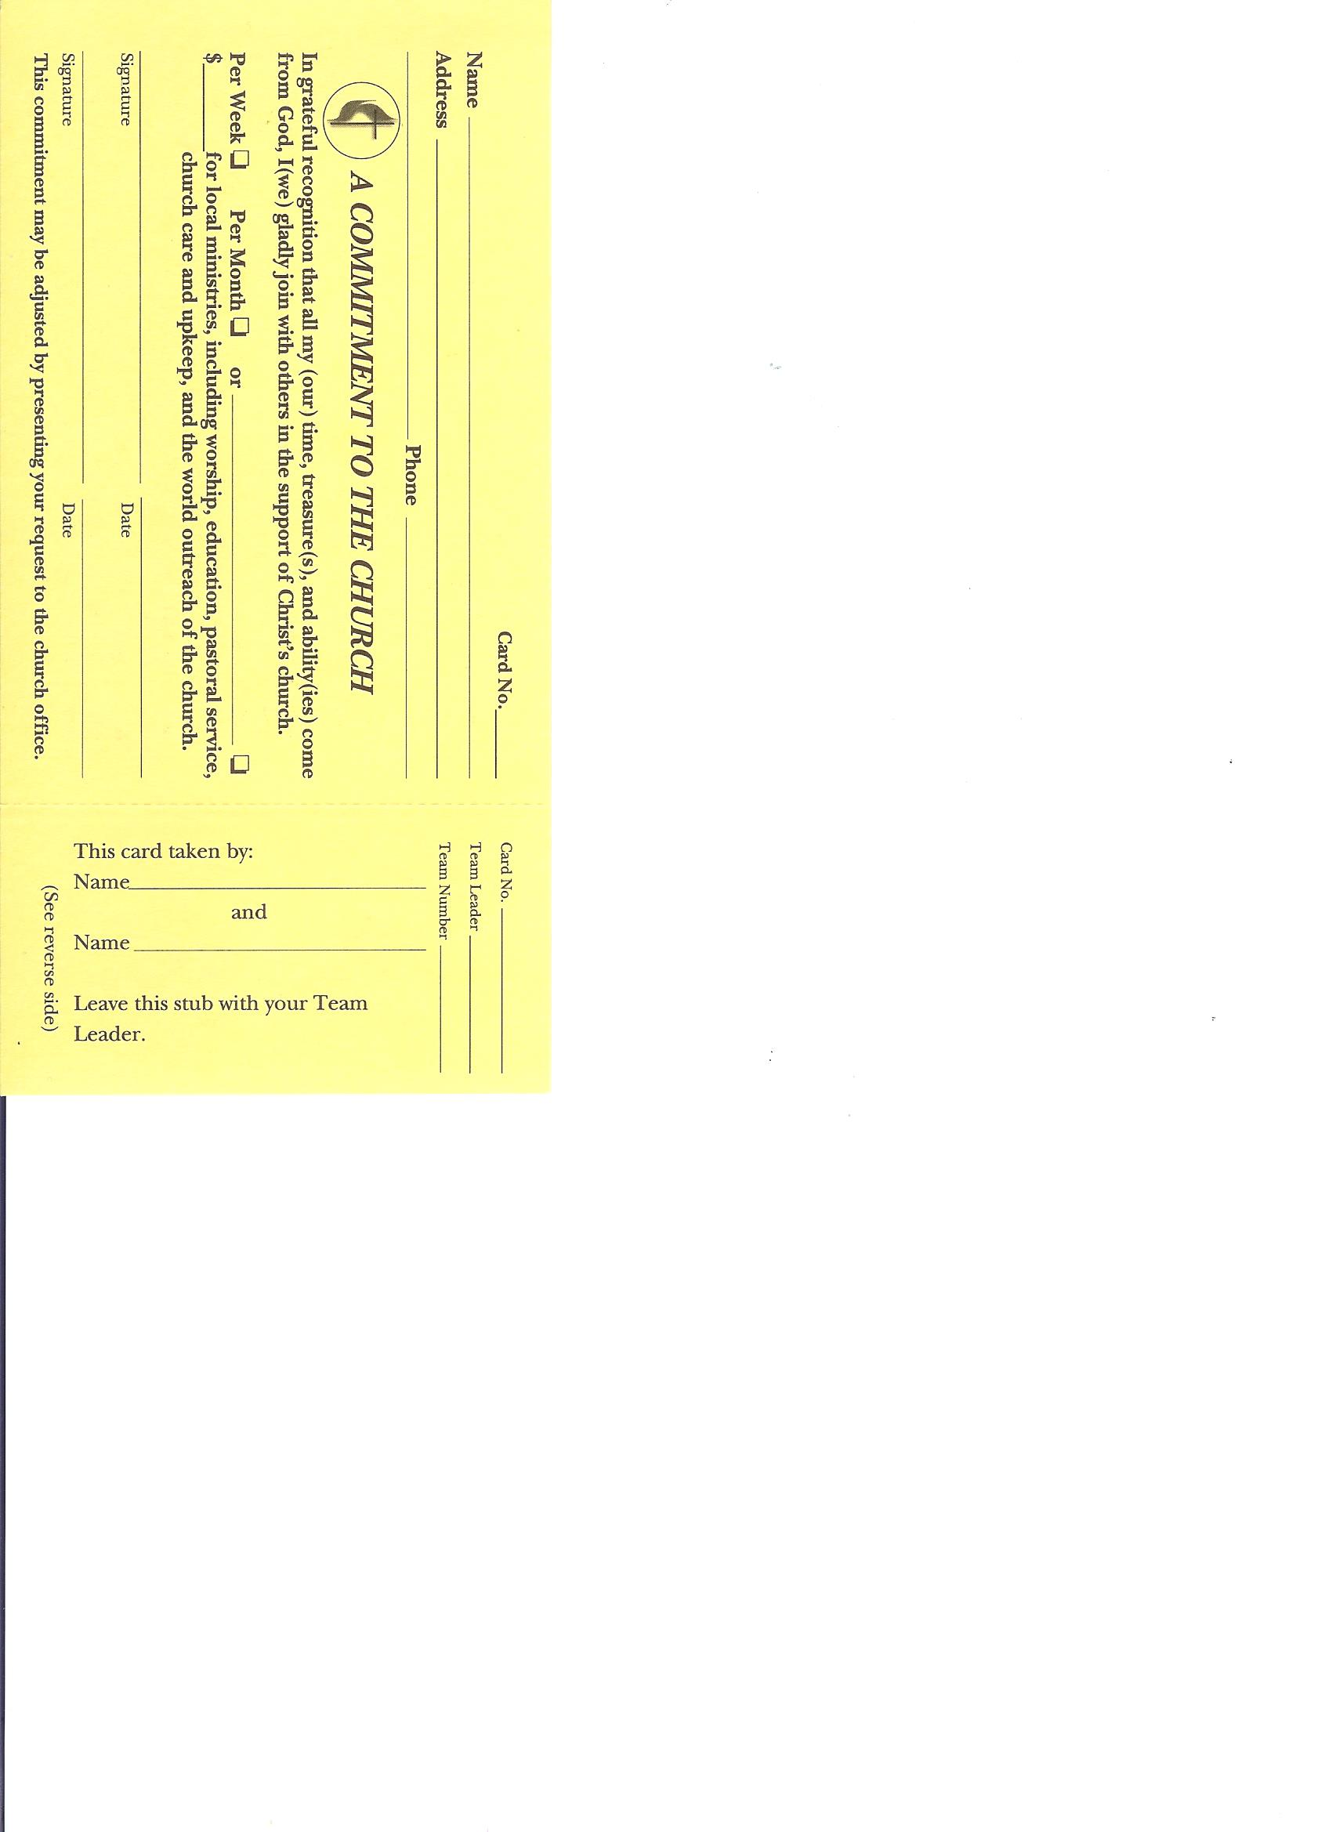

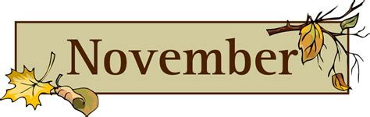

**1st*Daylight Saving Time Ends***

**All Saints Day**

**11th*Veterans Day***

C:\Users\Owner\AppData\Local\Microsoft\Windows\Temporary Internet Files\Content.IE5\GWZ1PHLX\MC900104344[1].wmf

**22ndAdministrativeCouncil Meeting**

Following Service (Lands Class)



**23rd10am Deadline for Poinsettia Orders**



**26th*Thanksgiving***



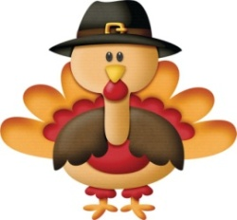



**12th Poinsettia delivery**



**24th Christmas Eve**

C:\Documents and Settings\Desktop\Local Settings\Temporary Internet Files\Content.IE5\U3T9ILL6\MC900363562[1].wmf

**25th Christmas Day**



**31st New Year’s Eve**

C:\Documents and Settings\Desktop\Local Settings\Temporary Internet Files\Content.IE5\VYI7ZDPX\MC900281864[1].wmf

Happy New Year 2021



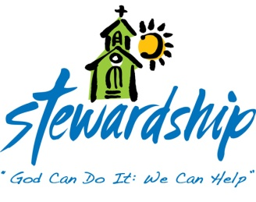

**October 4, 2020**

Church Attendance

In person/virtual - 27

Offering -$2,570.00

**October 11, 2020**

Church Attendance

In person/virtual - 27

Offering - $370.00

**October 18, 2020**

Church Attendance

In person/virtual - 31

Offering -$1,146.00

**October 25, 2020**

Church Attendance

In person/virtual –n/a

Offering -$40,222.92

Commonwealth

United Methodist Church

2434 Commonwealth Ave.

Charlotte, NC 28205-5132

704-376-4924

October 27, 2020

*Steve Kurt* - Pastor