Pastor’s Walk

Now the eleven disciples went to Galilee, to the mountain to which Jesus had directed them. When they saw him, they worshipped him; but some doubted. And Jesus came and said to them, ‘All authority in heaven and on earth has been given to me. Go therefore and make disciples of all nations, baptizing them in the name of the Father and of the Son and of the Holy Spirit, and teaching them to obey everything that I have commanded you. And remember, I am with you always, to the end of the age.’(Matthew 28: 16-20)

The scripture quoted above is often referred to as the “Great Commission.” That is…these words of Jesus are and should be the commissioning statement of every church which proclaims Jesus Christ as Lord and Savior. As such, we should be always looking for ways and means for engaging the Spirit of Christ with the expressed purpose of engaging others so that they may learn and discern from that same Spirit discipleship in Christ Jesus. Discipleship is just another way of saying…becoming open to new learning. And that is really what we are as followers of Christ Jesus…lifelong learners of something new…a new way of seeing things…a new way of being…a new way of engaging one another…a new way of life.

As a church, this means we must be constantly looking at the way we are doing things and asking ourselves if we are embracing the new…new viewpoints…new ways of reaching out…new ways of engagement…new ways of creating new life in others. It is a challenge because this commission asks us to do something that isn’t natural for us. Left to our own devises, the majority of us would just love to fall into some sort of routine…establish a status quo…be assured in knowing we always know exactly what will happen. Don’t get me wrong, routines are not a bad thing. As a matter of fact, I am big fan of routines and I often live to create routine in a very hectic life. However, left to function on their own, routines can create in us complacency and a willingness to settle and generally feel like we should just leave well enough alone.

In the church, that is called to engage in the “Great Commission” with all of its energies…called to reach out “to all nations, baptizing them in the name of the Father and the Son and the Holy Spirit” this falling into the quagmire of routine can and does look like fewer and fewer baptisms and fewer and fewer professions of faith. And eventually, if the church does not recognize this comfort with routine, they will go for years and years without a baptism or profession of faith…so much so that the baptismal font will become dusty and the liturgy of baptism forgotten in the hymnal. And please note that none of this has to do with membership. Even churches with increasing membership can fall into the quagmire and forget the “Great Commission” while they focus more on numbers and ever increasing revenue. Membership in the church is not the reason for the commission…teaching folks about Jesus…introducing folks to the love of the Father…encouraging more and more people to engage the Spirit is what Jesus was talking about…not membership in some club down at the building with the big steeple.

The “Great Commission” is not about us….it is about Jesus and continuing the work of Jesus Christ in this world!

So here is the question I have for us here at Commonwealth UMC. When was the last time we had a baptism at Commonwealth…when was the last time we experienced someone coming to Christ through a profession of faith?

It is a good question we need to ask ourselves. I suspect it will be a hard question in which to hear the answer. It is going to be even harder to allow the answer to that question to guide us into the future.

However, it is a question we must ask of ourselves and an answer we must not shy away from…and more importantly we must not be afraid of what asking and answering that question brings for us at Commonwealth and beyond! We must not be afraid to engage in that same Spirit which has guided us into believing and encouraged us to become a part of His church as we step out of our routine and into the new…the newness of a new chapter for us all and for the life of our community in Christ Jesus.

Grace,
Rev. Steve Kurt
What about that merger thing????

I am sure many of you are wondering about the merger talks with Memorial. Well, first I want everyone to realize that they were just talks. Really, we were just having a conversation between two struggling churches seeing if we could help one another out as we move into the future. The chances of this happening were slim and the chances of getting the conference’s blessing were even slimmer. Second, both Commonwealth and Memorial were in charge of the direction of these talks from the get go. That is we both had a say and we both had an equal voice in what was decided. And, most importantly, we both had the ability to simply walk away…no questions asked…just say, “This does not sound like it is for us and move on.”

That is exactly what happened. Both parties investigated the possibility and we discerned that this was not an appropriate course of action for either of our churches. Memorial has developed, for itself, a course of action and I am sure all of us at Commonwealth wish them luck. We will also continue to be in ministerial partnership with Memorial as we both share some of the same Spiritual DNA. Going forward, I am hopeful we can engaged in many combined worship experiences, learning opportunities and missions within the community together.

So, what does this mean for Commonwealth UMC? That is a good question and one I am hopeful we will spend the rest of the year figuring out the answer. Financially, we have stabilized for this year thanks to some generous gifts. However, we cannot continue to rely on generous gifts to bail us out every year. The truth is, our tithes and offerings are not even coming close to paying the bills and we have to rely more and more on rental income and unplanned gifts. Our budget has been cut to the bone and to cut it any further would mean making some major sacrifices in personnel and in building usage. Finances aside, we at Commonwealth must start to take a serious look at our abilities to reach out into the community. I asked the question earlier in this newsletter…When was the last baptism or profession of faith at Commonwealth UMC? Well, let me tell you the answer is…a long, long time ago. To be honest, from what I can tell from our records…baptisms and professions of faith have been sort of the exception not the rule for Commonwealth for too many years now…too many decades now.

The fact is…we need help and we need energy and we need new folks to come and join us in ministry. In order to create this needed help and energy, we are going to need to make some changes…probably some very uncomfortable changes. There is truth in the saying that to continue to do the same thing you have been doing and expecting different results is the definition of insanity. For us to continue to “do” church in the same manner as we have always done and expect folks to just show-up and help-out…well...how do you all think that has been working out? This is the question I will be pushing us to ask of ourselves this year and into the next. I will also be pushing us to come up with some honest answers and, hopefully, some new solutions. Personally, I have given this a lot of thought and prayer and the only solutions I am coming-up with are some sort of merger with a larger church or a new church plant within the walls of our existing church. Will either of these ideas continue Commonwealth on in the form it is today…well no…study after study is telling us that the way church has been done in the past is having absolutely no impact on the current generation or the next. As a matter of fact, people are leaving the church faster than they have ever had before. Something I suspect we are all greatly aware of as we look around most Sundays and see more pew than people.

So, the merger with Memorial will not be happening. However, the future of Commonwealth UMC will greatly depend on the decisions we make here in the very near future. Right now, the power is in our hands to decide where this future lies. I cannot say that in a few months as 2019 turns into 2020…as the next General Conference approaches and who know what happens to the United Methodist Church next year that our future at Commonwealth will necessarily be in our hands anymore.

Grace,
Pastor Steve

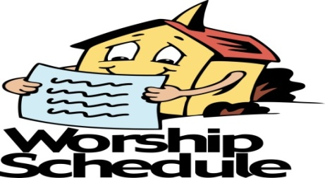

August 25: 11th Sunday after Pentecost
Scripture: Jeremiah 1: 4-10
Sermon: “Mouthpiece”

September 1: 12th Sunday after Pentecost
Communion
Scripture: Jeremiah 2: 4-13
Sermon: “Where is the Lord?”

September 8: 13th Sunday after Pentecost
Scripture: Jeremiah 18: 1-11
Sermon: “Time for a New Pot!”

September 15: 14th Sunday after Pentecost
Scripture: Jeremiah 4: 11-12, 22-28
Sermon: “When Mama Ain’t Happy”

Sympathy

The Commonwealth Church family would like to express its sympathy to the family of Rev. Frank Edwards, who passed away on Friday, August 2, 2019. Rev. Edwards was a former Commonwealth minister from 1972 – 1977.
May God comfort them in this time of grief and sorrow.

Thank You

I would like to thank everyone for the calls and cards you sent to me. Also for your prayers.
Marie Rich
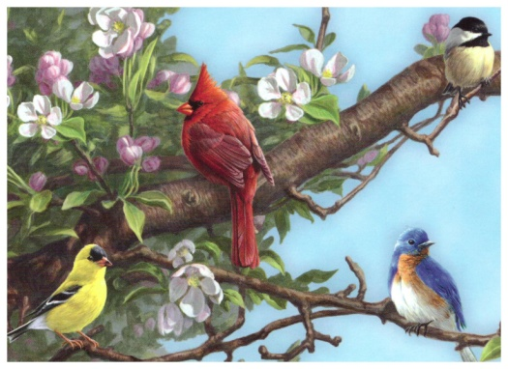

Thank You

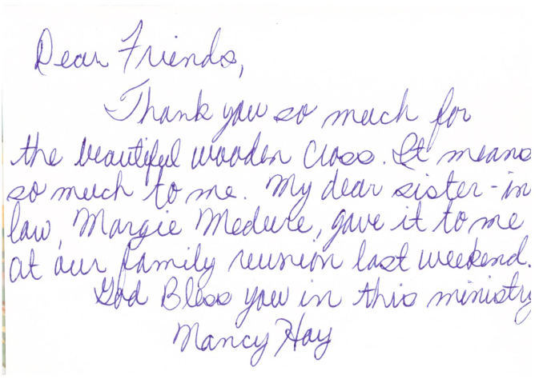
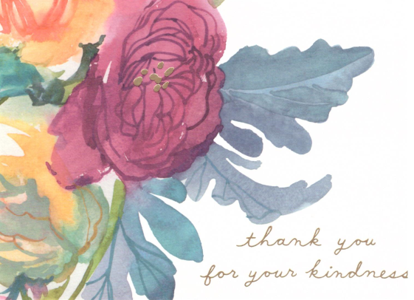
September Birthdays

2 Walter Rich, Jr.
16 Peggy Bridgers
18 Kay Little
27 Elise McMillion

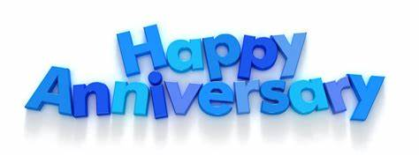
September Anniversaries

8 Nancy and John McNamara
12 Shirley and Leonard Laye
15 Sherry and Chris Ruane

Church Office Closed
Monday, September 2nd

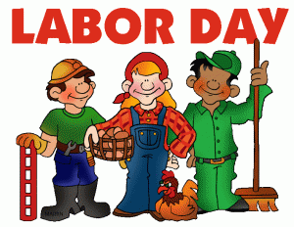

Wesleyan Circle

Tuesday, September 10th

12:30pm

Church Office

Administrative Council Meeting
Sunday, September 22nd at 12pm
Fellowship Hall

Memorial Gifts

In Memory of: Hazel Lands
By: Robert and Felicia Peaseley

Outreach Update & Thank you!!!

I like to say a huge thank you to everyone that participated in our canned food drive. Summer is a particularly hard time for food pantries to stay stocked. We donated 88 pounds of food to Second Harvest Food Bank.

Rita’s Italian Ice fundraiser for UMAR was a blast! We enjoyed a nice cold treat and some good fellowship time while 20% of the proceeds went towards helping adults with intellectual disabilities in our community. We earned a total of $116.04 for UMAR. We even got to socialize with some of their residents.

We have been collecting school supplies for Billingsville Elementary school during the month of August. Thank you for supporting our schools!
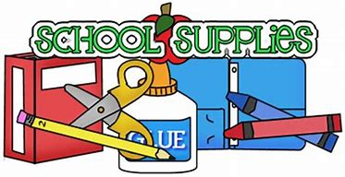
The Clothing Closet continues to be opened on the second Thursday of every month from 4-6. Thank you to Gene, Dawn and Hannah for running it in August. We had a good turn out and distributed many clothes!

Prayer Group

Wednesday’s at 6pm
Mary Pearre’s house
Prayer box located in the Narthex

Our Prayer List

Joann Fitzsimmons, Jack Harwell (brother of Ruby Agnew), Alma Horne, Nancy Hoy (sister-in-law of Margie Medure), Pat Inman (sister of Jackie Samuels), Maxine Kincaid, Rosemary Lands, Martha Lee, Anne Lever, Hue Parnell, Jean Stoneman

Flowers on the Altar

Dates are still available if you would like to put a small vase of flowers on the altar “in memory of” or “in honor of” an individual. Please fill out the sign-up sheet located in the Narthex.

Thank you in advance for adding a “special touch” to our worship service.

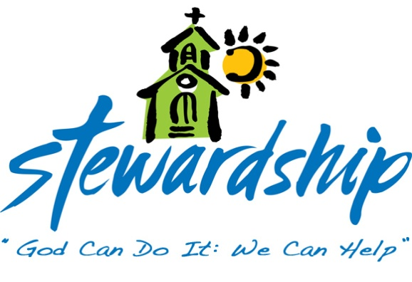
July 21, 2019
Sunday school - 9
Church Attendance - 30
Offering - $646.00

July 28, 2019
Sunday school - 6
Church Attendance - 36
Offering - $5,213.98

August 4, 2019
Sunday school - 9
Church Attendance - 28
Offering - $1,378.00

August 11, 2019
Sunday school - 13
Church Attendance - 51
Offering - $1,113.00

August 18, 2019
Sunday school - 9
Church Attendance - 28
Offering - $2,096.00

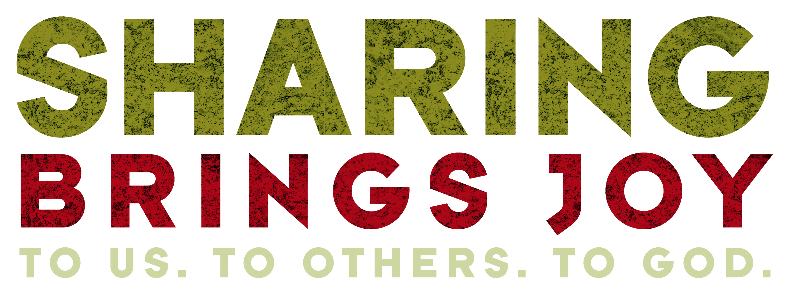

Commonwealth
United Methodist Church

2434 Commonwealth Ave.
Charlotte, NC 28205-5132
704-376-4924

August 20, 2019

Steve Kurt - Pastor
Patience Brumley - Pastoral Care

Sunday School - 10:00am
Worship Service - 11:00am

Office Hours
Mon. - Thurs. 9am to 1pm

