Pastor’s Walk

Well…it has been an interesting week…to say the least. As I sat down to write this month’s Pastor Walk, an email came across my computer from the Bishop of our Western North Carolina Conference. When the Bishop sends out an email, you learn quickly as a pastor to make time to read it. Imagine my surprise when I read Bishop Leeland telling us, the clergy of the Western North Carolina Conference, that he was suspending all public worship for the next two weeks because to the COVID-19 virus.

I can tell you in the five years I have served in this conference; I have never received or even heard of others receiving an email like this one! Truly, we are in uncharted waters these days and when you are not sure as to where you are going; the best bet is to follow the captain and do what they say. So…public worship is suspended for the next two weeks at CUMC and let’s all pray that in two weeks we can all look back and say, “That wasn’t too bad.”

The truth is, with this virus, we are all in uncharted territory and we are all left scratching our collective heads and saying how long is long enough…how severe is protective enough…how can we best protect ourselves and our love ones…how many more difficult decision will we have to make in the name of public health and safety?

I was talking with someone about all this just the other day…and the answer is…we do not know. And to be honest, not knowing, is just a little uncomfortable. Alright, it is a lot uncomfortable! Can we just say, it is worrisome and disconcerting and scary!

But…there is good news to be had…even when public worship is suspended for two weeks by the Bishop. The good news is that Christ still died for all our sins…that we are not alone in our suffering…that the Holy Spirit is just a breath away…that we have been given an awesome new life in the resurrection…that we are, indeed, children of God and loved by God with such magnitude that it boggles the mind!

So, my brothers and sisters in our most magnificent and loving God…when the news gets to be too much…when you are feeling worried and scarred….when things are just a little too unknown and different and not the way they are usually…when you do not know what else to do…pray.

I can guarantee God is just waiting to hear from you….that in your prayer you will find some rest…some assurance…some comfort. It may seem dark right now…as dark as it seemed on that day when our savior died on the Cross for us all. However, a new day will dawn…darkness will be overcome by the light…resurrection will occur. Remember my fellow Easter people…we are the children of the loving and conquering and ever living Christ Jesus. And it is this fact which we can all take comfort in and rely upon…and maybe…just maybe…we could all stop buying toilet paper like it was going out of style.

Grace,
Pastor Steve

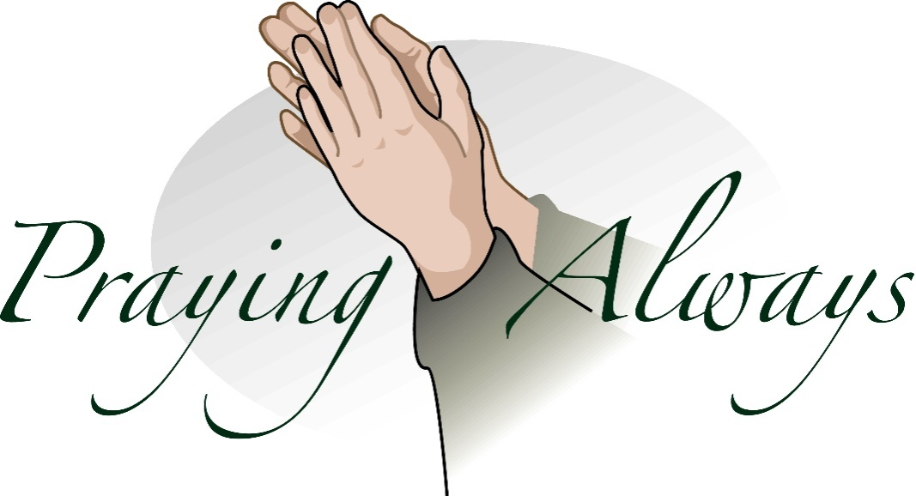

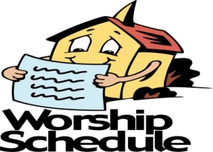

March 22: 4th Sunday of Lent
(Church canceled)

March 29: 5thSunday of Lent

April 5: Palm/Passion Sunday
Communion

April 10: Good Friday (7pm)

April 12: Easter Sunday
Communion

April 19: 2nd Sunday after Easter

Clothing Closet
Is openthe second Thursday of every month from 4-6pm.

Administrative Council Meeting
(Canceled)
Sunday March 22nd at 12pm
Fellowship Hall

Lenten services (canceled)

March 18 (12pm) - Amity Presbyterian Church
March 25 (6pm) - Central UMC
April 1 (12pm) - Third Presbyterian Church

Stay Safe and say a prayer wherever you are during these times.

Room in the Inn (canceled)

It is time to organize the dinner for our last Room in the Inn of the season. Right now, we are scheduled for Saturday March 28th arriving at 4 pm to set up. Due to the coronavirus, this activity has been canceled.

April Birthdays

3 Sagan Rich
7 Gene Hartsell
8 Karen Earnhardt
11 Jim Morrison
13 Sonya Garlick
20 Heather Eudy
24 Maxine Kincaid

April Anniversaries

16 Bob and Jackie Samuels

Good Friday Service
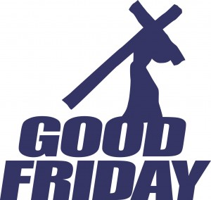

Friday, April 10th
7:00 p.m.
Here at Commonwealth UMC

Wesleyan Circle

Monday, April 13, 2020

12:30pm in the Church Office

Wednesday is Day of Prayer
Remember to pray for those in need.
Prayer box located in the Narthex

Our Prayer List

Jack Harwell (brother of Ruby Agnew), Alma Horne, Pat Inman (sister of Jackie Samuels), Maxine Kincaid, Rosemary Lands, Martha Lee,Jean Stoneman

Memorial

In Memory of: Marie Teague
By: Steve and Carol Jacobson

In Memory of: Sarah and Anne Lever
By: Steve and Carol Jacobson

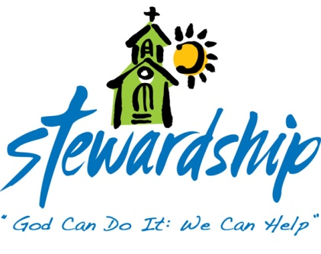
February 23, 2020
Sunday school -7
Church Attendance - 29
Offering -$2,316.00

February 26, 2020
Ash Wednesday
Attendance - 18

March 1, 2020
Sunday school - 10
Church Attendance - 33
Offering - $1,661,00

March 8, 2020
Sunday school - 10
Church Attendance - 36
Offering - $1,434.00

March 15, 2020
Church canceled
Due to COVID-19

Commonwealth
United Methodist Church

2434 Commonwealth Ave.
Charlotte, NC 28205-5132
704-376-4924

March 17, 2020

Steve Kurt- Pastor
Patience Brumley- Pastoral Care

Sunday School- 10:00am
Worship Service - 11:00am

Office Hours
Mon. - Thurs. 9am to 1pm

