**Pastor’s Walk**

I was listening to a news program on the radio the other day and they were talking about what parents could do to help their children cope more effectively with on-line learning. The number one suggestion was “routine”…parents establishing and enforcing some sort of routine into the learning process at home.

Creating a learning routine and how to do so in the classroom was one of the first things I learned in my education classes in college. Learning routines are really part of all teaching principles and the thing they teach us in college is that the students will hate these routines but secretly love, also. We all love to hate routines and often say to others “The last thing I want is to be stuck in some routine!” The truth is, we all secretly love routines and do some of our best work in those routines not just in the classroom but in life outside and beyond the classroom. What it all boils down to is given our druthers we all naturally fall into routines in our life…we just do not always like to have those routines forced upon us like they are in a school setting. But even those educationally imposed routines serve us better than no routine at all. And that is what educators, students, and parents have all been struggling with during this time of on-line education during the COVID pandemic…no routine.

We humans are made to be in routine and the last thing that many of us have had this past year or so is routine. I would also dare say that routine is something we are all desperately trying to return to these days.

For me, personally, I have discovered when it comes to the vast uncertainty that is life…my routine often helps be to better deal with the uncertainty. Having daily routines to hold onto gives me a better chance of surviving the daily craziness of life. This past year, I have often found myself craving routine and very much missing my normal pre-COVID routines for this very fact.

So, routine is important for us to live happy and healthy lives, but routine is not something easily obtained right now…what are we to do?

My answer and solution are Lent. This Lenten season offers us a unique opportunity to introduce routine into our lives. No, it may not be the same routine we have been able to enter during previous Lenten seasons but just because it is routine does not mean it necessarily needs to be the same. The beauty and wonder of Lent are that we are encouraged by the season to stop and consider our faith and how we live our lives in that faith. To do this, we need to both actively step out of our normal routine and, at the same time, enter a routine of faithful exploration. Or in the case of this year, we need to purposefully superimpose a routine of faithful exploration over the uncertainty of life during a pandemic. And here is the beauty of the Lenten season and these routines of faithful exploration we are encouraged to incorporate into our lives until Easter Sunday…it is completely up to us as to what those routines look like and how they are played out in our lives.

Perhaps you would like to spend these days reading all four Gospels in succession. To completely immerse yourself in the story of Jesus.

Maybe you would like to spend these days engaging in daily prayer three times a day…morning, noon, and evening. Or engaging in silent meditation. Or three times a day reading a passage of scripture…or…your pick.

It could be that you are leaning more to having your routine impacted during the whole day by fasting. Maybe fasting once, a week from sun-up to sun-down. Or Thursday evening to Friday Noon…or just Sunday…or maybe you will fast not from all food but just one food source like chocolate or soda or what have you. And during these times of fasting, you will spend purposeful time reflecting on your faith walk with Jesus.

There could be some devotion books out there that you have been meaning to read and this Lenten season is the time you are going to get them read. Every morning you will spend fifteen minutes reading and praying over those books. (I am reading two devotion books right now).

Lent gives us permission to establish routines around our faith and to spend time routinely discovering new depths of that faith…or just reminding us why we fell in love with Jesus in the first place.

I pray that you will all use this time of Lenten preparation to give yourself the gift of routine…to place within your lives a routine of prayer, study and reflection as we journey together to the foot of the cross of Jesus…as we wait with expectant hearts for the rock to be rolled away…as we relish the discovery of an empty tomb and as we all long to again say…well that is a story we will tell in about 40 days (not including Sundays).

Grace,

Rev. Steve Kurt

MC900048039[1]

**Fellowship Hall Update:**

They are making some real progress on the repairs to Fellowship Hall.  The HVAC ductwork has all been replaced and painted and all the water damaged wood has been removed.  Our contractor will now begin the process of putting everything back together and finishing any touch-up work that needs to be done.  With any luck and no delays, it looks like the work in Fellowship Hall may be completed by early to late Spring.

Grace,

Rev. Steve



**Our Prayer List**

Ruby Agnew

Jerline Bender (sister of Alice Shepherd)

Nick Carrington (uncle of Dawn Beaver)

Jack Harwell (brother of Ruby Agnew)

Alma Horne

Pat Inman (sister of Jackie Samuels)

Maxine Kincaid

Rosemary Lands

Martha Lee

Rick Morrison

Carol Painter

Mary Pearre

Donna Pruitt

Jean Stoneman



**Our Sympathy**

**The Commonwealth church family would like to express its sympathy to the family of Sarah Haigler who passed away on Sunday, January 31, 2021. Sarah joined Commonwealth in 1960.**

**May God comfort them in this time of grief and sorrow.**





**March Birthdays**

15 Marie Rich

20 Jean Stoneman

23 Martha Lee

30 Ken Lee, Jr.



**March Anniversaries**

21 Gene and Connie Hartsell



**Memorials**

**In Memory of: Sarah Haigler**

By: United Methodist Women

By: Commonwealth UMC

By: Anonymous



**6th Sanctuary reserved for Wedding.**



**13th Before going to sleep Saturday evening,**

**turn your clocks ahead 1 hour.**



**14th *Daylight Saving Time Begins***

**17th St. Patrick’s Day**



**28th Palm Sunday**



**29th Newsletter Deadline**





**2nd Good Friday**



**4th Easter Sunday**

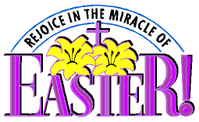

**5th Easter Monday**

**Church Office**



**26th Newsletter Deadline**



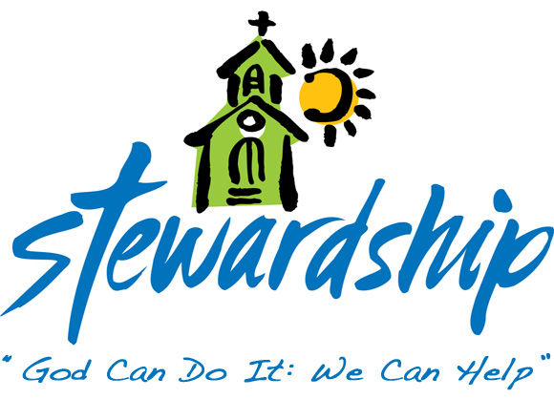

**January 31, 2021**

Church Attendance

Virtual – 23

Offering - $411.00

**February 7, 2021**

Church Attendance

Virtual - 27

Offering - $2,374.63

**February 14, 2021**

Church Attendance

Virtual - 24

Offering – n/a

**Ash Wednesday**

Virtual - 22

**February 21, 2021**

Church Attendance

Virtual - 24

Offering - $2,041.09



Commonwealth

United Methodist Church

2434 Commonwealth Ave.

Charlotte, NC 28205-5132

704-376-4924



March - 2021

*Steve Kurt* - Pastor

*Patience Brumley* - Pastoral Care

Office Hours

Mon. - Thurs. 9am to 1pm