Pastor’s Walk

Commonwealth Church Brothers and Sisters,

As we begin the process of reopening our economy, we must also begin the process of reopening the church and begin discerning how we will do “church” going forward into the new normal we are all now being asked to live. The truth is…how we engage in, participate in, and “do” church will need to change in the near as well as the distant future because the fact is, this virus has effected almost every aspect of our lives…including the church.
After consulting many resources…including our own Conferences Guidelines…the Administrative Council and I have determined that it is best we open with the following guidelines in July (be mindful that this is all a very fluid situation and depending on how things progress in our state and community will greatly affect how we proceed):
- Have a projected reopening date of July 5th.
  - The second phase of the Governors plan started on the 23rd.
  - In Phase II, the Governor has allowed houses of worship to reopen and gather.
  - I would like to be extra careful (and the conference has all but mandated that we are extra careful telling us to hold off on indoor worship until after June 30th) and give us a cushion thus the July 5th date.
- For the entire month of July we will be “worship only.”
  - This means we will meet only for worship and that worship will be truncated (about 30 to 45 minutes long).
  - Sunday School will continue to be postponed for July
  - Choir practice will also be postponed for July
  - There will be no Luncheons or other Sunday gatherings
  - The serving of any food or drink is greatly discouraged as of now
- While in Worship, we will practice social distancing (6 to 10 feet)
  - Every third pew will be open with the rest taped off
  - Families may sit together but individuals and separate family units will be required to sit 6 to 10 feet from one another
  - The Choir loft will be kept empty
  - There will be no congregational hymns sung (singing expels too much contaminant into the air)
  - For July, our music program shall consist of instrumentals only
  - There will only be three people up in the Chancel Area (Altar)
    - Myself, Patience, Janice
    - If someone comes up to sing a solo (after July) or read, Patience or I will move
  - Greeters will stand back from the door and bulletins will be placed on a table for folks to get themselves (we may eliminate Greeters if it is deemed they cannot be kept a safe distance from others because of space constrictions)
  - Passing the Peace will be eliminated from service
  - Offertory moment will be eliminated
    - Folks will be encouraged to drop offering off in a secure and centralized location one at a time.
  - Communion will be offered but will be done in a way to greatly reduce contact and potential spread of potential virus germs.
- A group of volunteers will be formed to clean and disinfect the sanctuary and high touch surfaces two days after every service (probably Wednesday)
- The only spaces used in the church for July by the congregation will be the Sanctuary, bathrooms and office the rest of the church will be off limits to the congregation and visitors.
- Fellowship Hall can be used by those in AA (they will be asked to clean and disinfect Fellowship Hall after every meeting)
- There will be no Yard/Church Clean-up Days (individuals may come and clean-up on their own)
Everything that I am reading lately, when it comes to reopening church, is to control the expectorant from others (this is atomized spit and germs coming from our mouths and noses). It seems this virus loves to transmit itself from person to person via this atomized expectorant (the reason for no singing) and high touch surfaces (the reason for a disinfectant crew on Wednesday). The whole goal is to still worship together but do so while greatly curtailing the chances of potentially infecting one another. One story I have recently read in the news is about a church in Arkansas which had services in May. A number of people in this church became sick with the COVID-19 virus and their infection was traced back to the pastor and his wife. You see they had come to church….feeling perfectly fine…showing no symptoms and infected everyone they touched and breathed on that day. A few days later they started to show signs of the virus but by then it was too late. Many people got this virus from them and sadly one congregant died.
The truth is…even in July…even though we are all being careful and we are all taking precautions…one of us could show-up on Sunday and be carrying this virus; a virus that could potentially kill one of our friends and fellow congregants. With this in mind, I will also ask you all to consider wearing a mask to church for your protection and the protection of others. Perhaps you would rather not wear a mask during the entire service…and I understand I am certainly not going to be able to preach with a mask on, however, perhaps we could all agree that wearing said masks as we go to and from the building would be a good practice. Especially since those times of entering and exiting may make social distancing difficult.
I understand that these guidelines may make the process of “doing” church feel very differently. However, we must be cognizant of the health of each other and our visitors. And…really…when it comes to our God, it isn’t how we worship that is important….it is just that we worship together and prepare ourselves to go from our doors every Sunday ready to serve…in the name of the One who gave His all so that we may know true love and grace….Christ Jesus.

Grace,
Rev. Steve Kurt

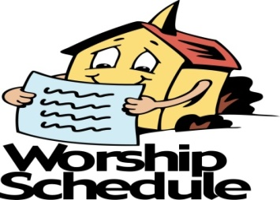

All Church activities have been postponed
until further notice

Just to be clear, the Church has not been closed, so it does not need to be re-opened. We have simply stopped worshipping in our buildings for a time to protect the health and well-being of our people and our communities. The Church does not require a building in order to be the Church. What is required is love, compassion and the presence of God.

Administrative Council Meeting
Sunday May 24th- cancelled

Wesleyan Circle

Hope to see everyone back in September.

June Birthdays

3 Christy Fitzsimmons
5 Margie Medure
13 Toni Batts
16 Mary Pearre
16 Donna Pruitt
19 Will Myers
19 Larry Coppala
20 Sandy Painter-Kurt
20 Connie Hartsell
23 Jonathan Beaver
30 Scott Laye

June Anniversaries

7 Nancy and Jack Wright
15 Margie and Ron Medure
15 Steve and Sandy Kurt

Wednesday is Day of Prayer
Remember to pray for those in need.
Prayer box located in the Narthex

Our Prayer List

Jack Harwell (brother of Ruby Agnew), Alma Horne, Pat Inman (sister of Jackie Samuels), Maxine Kincaid, Rosemary Lands, Martha Lee,Jean Stoneman
Sympathy

The Commonwealth Church family would like to express its sympathy to Donna Pruitt and her family in the passing of her mother, Vivian Pruitt, who passed away on Sunday, April 26, 2020.

We would also like to express of sympathy of Raymond (Dink) Hughes and his family in the passing of his wife, Nancy Hughes, who passed away on Friday, April 24, 2020.

We would also like to express of sympathy to Alma Horne and family in the passing of her brother, Earl Pinyon, who passed away Friday, April 29, 2020.
May God comfort them in this time of grief and sorrow.

We want to support our neighbors in this tough time. The free lending library has been turned into a free food pantry for the next 8 weeks.

Memo from Phyllis:
Good afternoon, everyone. I hope everyone is safe and secure in your homes.

I wanted to give an update on our new Free FoodPantry. We opened it yesterday (Monday, May 18th) putting in canned goods and non-perishable items, and people are using it!

A couple of us just stocked the pantry again. Since the spaceis so small, we placedthe extra canned goodsin the church office nursery on an empty shelf unit in the rightcorner of the room as you enter. If you should bring any food to the pantry and it looks full, and the office is closed,please contact Phyllis Batts.

Thanksto all who want to helpin this mission. Weare so excited that people are really noticing the little pantry and using it.

Stay safe, and, if you need me to deliver any food to the pantryor collect any donated money toward that goal, just give me a call, and I will takecare of it.

Hope to see you all soon.
Sincerely,
Phyllis Batts
704-517-2301 (cell)
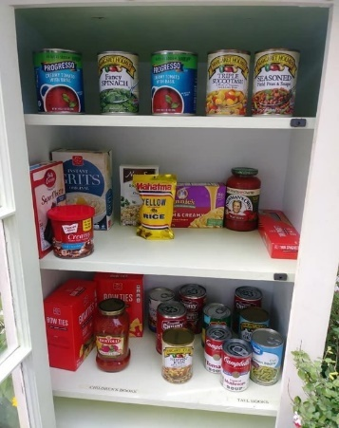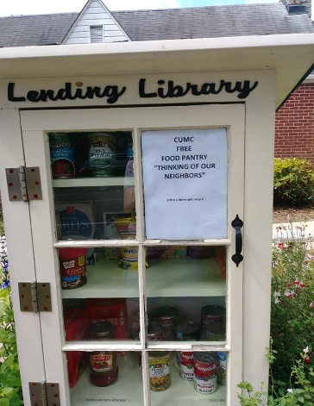

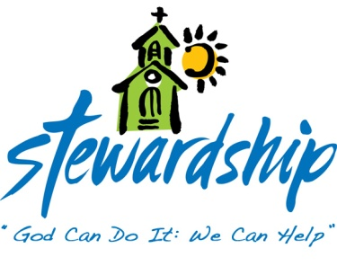
April 26, 2020
Church canceled
Offering - $1,936.50

May 3, 2020
Church canceled
Offering - $700.00

May 10, 2020
Church canceled
Offering –n/a

May 17, 2020
Church canceled
Offering - $2,085.00

May 24, 2020
Church canceled
Offering –n/a

Commonwealth
United Methodist Church

2434 Commonwealth Ave.
Charlotte, NC 28205-5132
704-376-4924

May 26, 2020

Steve Kurt- Pastor
Patience Brumley- Pastoral Care

Sunday School- 10:00am
Worship Service - 11:00am

Office Hours
Mon. - Thurs. 9am to 1pm

