Pastor’s Walk

The other day I overheard someone saying, “I just wish things would hurry-up and get back to normal!” A sentiment, that I must admit, I have shared on occasion these past few months. Then they said something that made me stop and think. They said that their “best bet was to simply go inside and lock the door and stay in there until things were normal again!”

And I thought….not going to see them for a few years…or more! Because I am not too sure normal exists anymore or…..if it ever did.
So, I have been thinking about normal and just what is normal. The definition that most of us use for normal goes like this: conforming to a standard; usual, typical, or expected, average conditions….you know exactly what we think should happen….right?

Here is the inherent issue with normal. My normal and let us say the normal of the guy living down the street and the girl living up the street and the couple living two streets away….well…they are not the same normal. Normal is very much more an “I” thing than an “us” thing when it comes to society. Sure, we can convince and cajole and pander to a concept of “normal” that we can sort of share and call our collective own. However, the reality is that even in that shared “normal” we will find as many different definitions of “normal” as there are people in said “normal” group.

The more I thought about it, the more I began to believe that “normal” is not….well….normal!

Here is what I know when it comes to “normal” and “being normal”

- I have never been good at the “normal” thing or even the “being normal” thing. I was just raised to be odd and a little off center….to think outside of the box more than inside the box. It is actually something I have learned to accept about myself and actually be grateful for in my life (although I will tell you, in middle school, I would have given anything to be “normal”).
- And this is the most important….as Christians, we are called by Christ to be anything but “normal.” Our faith is not “normal.” It never has been and it should never be considered the norm. Christ Jesus did not come to this earth so that we would be normalized to society. Christ Jesus came so that we would know a different way of life…a different way of living that life….a life so far out of the norm that one could say it is “other worldly” or at least not of this earth. And it sure was never nor is it still…”normal.”
Here is the deal; you and I are Kingdom builders. This is what God has tapped us to do here on earth…pray and work and help bring “thy kingdom come…thy will be done…on earth as it is in heaven.” Kingdom builders, in case you did not know this, are not normal…they are abnormal…they are out of the box thinkers…they answer to a higher out of the norm power (God)…they have a home here on earth and one in heaven and they know it….they are strange and they think differently and they see the world through different eyes and they react to worldly events with a different view point and they are sure and they are confident that there is a purpose and they…well they are not normal!

And that is what you and I, as followers of Christ…as purveyors of His Holy Spirit…as children of God are called to be….called to live…called to function….not in the normal.

My friends, let us all put to rest our desire for the “normal” and start living as Christ has commanded us to live…in the here and now with an eye to what will be!

We have wasted too much time, already, trying to get back to normal. Trying to shape our church into the church it used to be back in the past. Trying to conform to an ideal that we are sure we all share but find out time and time again that the only one who has that ideal is us. The church is not called to be normal….that is not our goal and nor should it have ever been our goal. Yet, if you ask those who are outside the church….those who are looking through our windows and into the soul of our church, do they see people who are embracing the new and scary and not so sureness of the future or do they see people desperately trying to hold onto a past….a “normal” that never really existed….except in our own minds and memories.

So here is what I am hoping for as we go forward into the future as a church body…I do not want “normal.” I want peace…and love….and acceptance….and the chance to serve….and the ability to reach out to the new…and I want to welcome and bless and…what I really want is to one day meet my maker and hear these simple words, “Well done my good and faithful servant. You lived your life not in the “normal” but in the light. Come and rest now in that light. Amen.”

Grace,
Pastor Steve Kurt

When we come back to worship as one?

As it stands right now, we are scheduled to resume in-person, indoor worship starting Sunday July 5th. Even though this date is less than two weeks out, we should look at it as a possible re-start date. A lot will depend on what the Governor says and then what our Bishop says we can do.

Personally, I am cautiously optimistic about the July 5th date but I am also well aware of the fact the way this virus is continuing to spread and is continuing to kill folks….and well, we may need to prepare ourselves to have July 5th come and go and still have indoor worship suspended. The truth is….I just do not know and the best we can do is wait and see.

However, let us talk about what worship will look like when we do come back whether it is July 5th or some later date this year.

- The guiding principle for our worship at CUMC will be safety and the well being of our congregation and guests….and we will error on the side of caution every time in this respect.

- It will be important that we all maintain and respect the social distancing policies established from the very beginning. This means staying at least 6 feet apart from one another and not shaking hands or hugging or even touching one another. For this reason, the choir loft will be closed and we will spread out when we sit down with only every third pew open.

- Facemasks are a must! Here is the deal, we must consider those times when social distancing will be difficult if not impossible (like when we enter and exit the building). In these cases, we must ALL be wearing face masks so as to minimize the spread of atomized moister (spit). I am not saying you have to wear your mask during the service…just when there is a chance you will need to break the 6 foot barrier. I know, wearing facemasks is strange and uncomfortable….I hate wearing them too….but they are necessary and they help keep us and others safer and help prevent the spread of this virus.

- The service will be shortened greatly. We have developed a worship plan going forward that has the service lasting only 35 to 40 minutes.

- Certain aspects of the service will be eliminated for a good while. They are: Extending the Peace of Christ to each other….Offertory (passing the plate)….singing (choir and congregational). It is unclear when these aspects will be allowed back into the service at this time.

- We are going to take a break from offering Communion (at least for the first month). I still have a lot of reading and research to do on how to offer Communion safely and then figuring out how to do that within our church. Communion will be offered again soon…it will just be done in a very different manner.

- Sunday school and Choir practice will be suspended for the foreseeable future. I know this is not what anyone wants to hear. Remember, our first guiding principle….keep people safe and error on the side of caution. For right now, we just need to limit our exposure to one another and thus limit the potential virus exposure.

- We do not want anyone to feel like they have to come to Sunday worship if they are still unsure if it is safe. For this reason, we will attempt to post a recording of the Sunday worship on YouTube. I say “attempt” because we may find that we do not have the equipment or skill to do this well and if you are posting videos on line they must be done well (because they are there forever)!

- For the remainder of the Summer and probably into the Fall, there will be no luncheons or gatherings with food in the Fellowship Hall or anywhere else in the church. Sharing food is one of the fastest ways to spread this virus so we need to just say “No.”

- We need to prepare ourselves for the chance that worship may be suspended again in the fall if this virus makes a resurgence in connection with the Flu…pray very hard please that does not happen!
So, I have just listed a number of things we will not have in the service going forward…what will we have?

We will still have God’s Holy Spirit abounding all around us!

We will still have the Power of God behind us, beside us, and walking before us!

We will still have one another and we will still keep each other in prayer!

We will still get to greet each other (from a distance) and pray together and hear the Word as one!

We will still be the church…just as we have always been….just as we have been whether we have been able to meet together or meet together apart!

We will still be loved and held closely by a God who is just crazy about us and wanting nothing more from us than to know we are loved in ways we cannot even comprehend!

And really….what else do we need?

Grace,
Rev. Steve Kurt

Administrative Council Meeting
June meeting cancelled for now

Wesleyan Circle

Hope to see everyone back in September.

July Birthdays

3 Billie Gardner
4 Steve Myers
4 Alma Horne
9 Virginia Odom
11 Larry Laye
13 Heather Cribb
20 Mildred Wong
21 Kristin Jordan
22 Perry Beaver
26 David Haigler
27 Frances Lynch
28 Ann Hodge
29 Bill Teague
Wednesday is Day of Prayer
Remember to pray for those in need.
Prayer box located in the Narthex

Our Prayer List

Jack Harwell (brother of Ruby Agnew), Alma Horne, Pat Inman (sister of Jackie Samuels), Maxine Kincaid, Rosemary Lands, Martha Lee,Jean Stoneman

Honorarium

In Honor of: Mary Pearre
By: Sheila and Tommy Sanford

Memorial

In Memory of: David Elder
By: Peggy Elder
(Donation to Food Pantry)

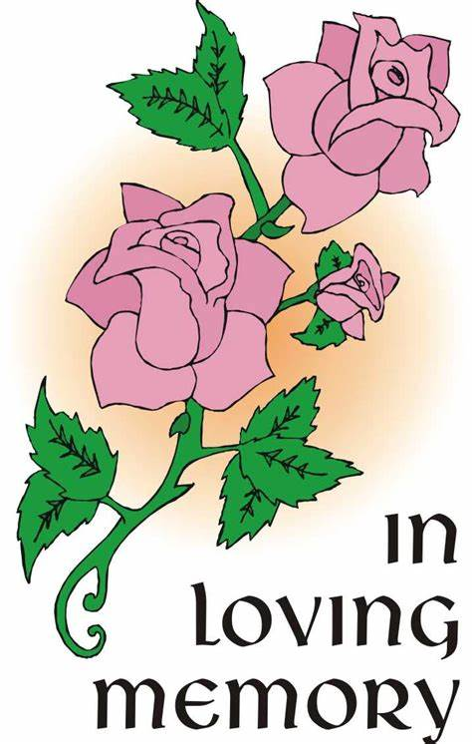

We want to support our neighbors in this tough time. The free lending library has been turned into a free food pantry for the next 8 weeks.

Memo from Phyllis:
Good afternoon, everyone. I hope everyone is safe and secure in your homes.

I wanted to give an update on our new Free FoodPantry. We opened it yesterday (Monday, May 18th) putting in canned goods and non-perishable items, and people are using it!

A couple of us just stocked the pantry again. Since the spaceis so small, we placedthe extra canned goodsin the church office nursery on an empty shelf unit in the rightcorner of the room as you enter. If you should bring any food to the pantry and it looks full, and the office is closed,please contact Phyllis Batts.

Thanksto all who want to helpin this mission. Weare so excited that people are really noticing the little pantry and using it.

Stay safe, and, if you need me to deliver any food to the pantryor collect any donated money toward that goal, just give me a call, and I will takecare of it.

Hope to see you all soon.
Sincerely,
Phyllis Batts
704-517-2301 (cell)
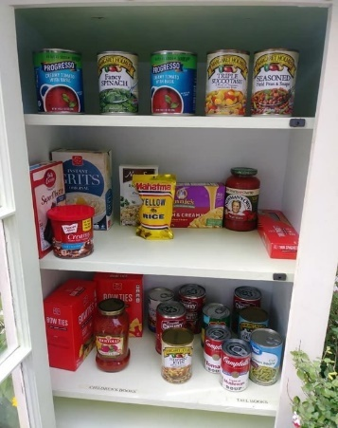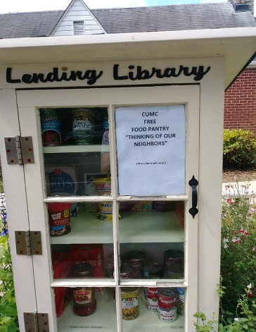

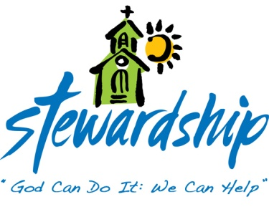
May 31, 2020
Church canceled
Offering –900.00

June 7, 2020
Church canceled
Offering –$1,310.00

June 14, 2020
Church canceled
Offering –$0.00

June 21, 2020
Church canceled
Offering –$1,615.67

Commonwealth
United Methodist Church

2434 Commonwealth Ave.
Charlotte, NC 28205-5132
704-376-4924

June 23, 2020

Steve Kurt- Pastor
Patience Brumley- Pastoral Care

Sunday School- 10:00am
Worship Service - 11:00am

Office Hours
Mon. - Thurs. 9am to 1pm

