Pastor’s Walk

Over these past few months, it has been a struggle for us all to stay connected to one another. Either we have needed to stay at home for the safety of ourselves and others or the risk of viral infection has been too great to gather in any real and meaningful way. Even within our own extended families we have had to make some hard choices and take some mightily unprecedented precautions when it comes to gathering (Sandy and I can tell you that planning a wedding during a pandemic is no picnic). Loneliness has become very real for many of us and we have experienced that loneliness and sense of isolation in very new and often uncomfortable ways. And we are all more than ready to get back to our lives…our normal lives!

With this said, I understand our desire to come together as a church family again. I also know that many of you have questions and concerns about our church and, I suspect, many of you are wondering if we will ever have services at Commonwealth UMC again….and you are not alone.

I believe that we all benefit from knowing and in knowing can benefit all so here is a little FAQ I have put together to help us all be on the same page going forward:

- Has the conference given a projected start back date for in-person and in-door worship?
    - No, the last communication I received from the conference simply stated, “All in-door, in-person worship should be suspended until further notice.”
- Can we worship together in other ways?
    - Yes, we can continue with on-line worship, outdoor worship (with restrictions) and drive-in worship and house churches (with restrictions).
- Why are we not engaging in outdoor worship at CUMC?
    - Truthfully, we do not have the sound equipment or broadcast equipment to properly put this kind of worship together.
    - We also do not have the room in our parking lot for a drive-in worship if we did. Cars must be parked staggered in every other space meaning our lot could hold about a dozen cars.
- Can we meet, in-doors for bible study?
    - Yes, in groups of less than ten and with social distancing and with masks (that last one is my rule). These studies should be short (15 minutes) and they should have no food or beverages involved.
    - Personally, I am still unsure if the risk outweighs the benefits of doing this kind of study at the church.
- When we can come back to church will worship be the same?
    - In a word, No, worship will not be the same. There will be no singing for the foreseeable future (both choir and congregational). We will need to wear masks during the service. The way we engage in communion will be completely different. We will all have to respect the social distancing requirements which will mean no passing the peace or passing the plate or sitting together outside of our family units. Worship will also be greatly shortened (30 to 40 min). There will also be no food our beverages served which means for CUMC…no more luncheons or breakfasts until further notice!
    - How long these worship restrictions will be in place is anyone’s guess right now. I am planning on the conference having these restrictions in place until Christmas and/or beyond.

- How is Commonwealth fairing financially and can we survive this?
    - I saved the hardest question for the last. Financially, we are holding our own…although we could be doing a lot better, things are not as bad as they could be. It helps that some bills have been lowered, however, there are certain expenses that must be met whether we are having services or not and we are potentially looking at some major expenses (see Fellowship Hall Closed) so please keep sending in your tithes and offerings to the church office. We are going to eat into our savings before everything is said and done…. but hopefully that eating will be kept to a minimal with continued support from the congregation.
    - As for surviving…this is the question that keeps me up at night and the one that constantly swirls in my head during prayer. And, honestly, my concern is not just for CUMC but for the whole church. Before the pandemic, I think we can all agree that the big “C” church was struggling to make an impact in this world. We were experiencing decline and disinterest as we failed time and time again to reach out in real and meaningful ways. The pandemic has not helped in these efforts and I am afraid with the news constantly covering those churches that defied medical warnings and had services anyway only to become superclusters of infection…we have an even steeper hill to climb. At CUMC, well you all know that the church is more than just the building and the bank accounts…it is the people. We have got some great folks in our church and they are testaments to the power of the Holy Spirit in many ways. So, in that respect we will be fine and CUMC will certainly survive. However, when it comes to the business of the church there is a minimum number of folks necessary to make a church with very old buildings work and keep the doors open. So, what keeps me up at night and what I pray for daily is that we at CUMC will be able to keep moving forward with our limited numbers and, perhaps, with even more limited numbers due to the pandemic. Because the truth is, some folks will not feel comfortable rejoining services and some will not be able to because of health concerns and some…well they may move on to other church families that are closer to home. And we will pray for these folks and wish them well and they will always be a part of our family. Our survival will depend on the same things we have already been doing, finding ways to adapt and “do” church in ways that help us to move forward in Christ. What will that look like…well that will be up to us and how willing we are to let the Holy Spirit guide our way…to change and adapt…to let go of some things and hold tight to others but mostly become the community of faith God would have us to become in Christ.
I hope this helps and know that you are loved by God in ways that you can only begin to imagine, and in that love, you are in my prayers.

Grace,
Rev. Steve Kurt
Fellowship Hall Closed!

Until further notice, Fellowship Hall is closed. As some of you may already know, we had a sewage back-up in Fellowship Hall on July the 4th. The damage from the back-up was extensive but not as bad as the last back-up we had. We are still not sure why the back-up arrester we installed after the last one did not work. However, during the process of trying to get this latest back-up cleaned up it was discovered that asbestos dust was present in the HVAC ductwork (possibly caused by the floor work done after the last back-up).

Because of the presence of the asbestos, all work on Fellowship Hall has been halted until we can figure out how to best proceed and who is going to pay for it all. The good thing is that the sewage has been cleaned-up and the area has been disinfected. All that is left to do is repair some woodwork and possibly some drywall but none of that work can continue until the asbestos is dealt with completely. The bad thing is that the asbestos dust in the duct work probably means we will have to replace most if not all the HVAC in Fellowship Hall after having an asbestos abatement company take away our existing HVAC system.

Needless to say, this is going to be a very expensive endeavor so we are working with the insurance company right now to see if it would be covered by our policy and, if so, how much would be covered. The sewage clean-up is completely covered…the asbestos clean-up, well that remains to be seen.

The bottom line is that until we get this all figured out and fixed up, Fellowship Hall is closed to all meetings and gatherings.

Grace,
Rev. Steve Kurt

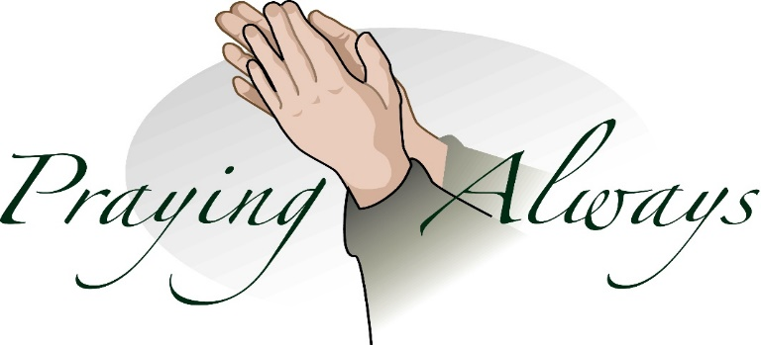

Food Pantry

Back in May, the City of Charlotte granted our church $150 to start our free food pantry for an 8-week period, and it went very well.

For your information, that 8-week time frame for the Free Food Pantry has ended. In fact, we went 10 weeks with our donations of food. I'm not sure who all gave to this effort, as some of you donated money for the pantry directly to the church office and/or hand delivered the food and placed it in the pantry.

We so appreciate your giving for this undertaking. It was a much needed supply of food to the neighborhood, and the people I ran into while they were getting their food said they appreciated the church doing this for the community. I saw some residents who were there putting canned goods in to help us with supporting the pantry.

We will return to our Little Library in the coming week.

Thanks again to all who participated. It was a fun project for our church to give to the community.

Phyllis Batts

Church Monthly calendar

With church being closed and all church activities being canceled until further notice, there is nothing to add to the church calendar at this time. We have decided to suspend printing the monthly calendars and will start again when the church activities resume. Sorry for any inconvenience or confusion this may cause individuals.

All Church activities have been postponed
until further notice

Just to be clear, the Church has not been closed, so it does not need to be re-opened. We have simply stopped worshipping in our buildings for a time to protect the health and well-being of our people and our communities. The Church does not require a building in order to be the Church. What is required is love, compassion and the presence of God.

August Birthdays

1 Ana Pearre
2 Alice Shepherd
3 Jackie Samuels
3 Shirley Laye
6 Sandra Pearre
19 Amber Gulledge
23 Jimmy Bivins
24 Alan Lee
30 James Woods
31 Ron Medure
August Anniversaries

23 Sonya and Glen Garlick

Wednesday is Day of Prayer
Remember to pray for those in need.
Prayer box located in the Narthex

Our Prayer List

Ruby Agnew, Jack Harwell (brother of Ruby Agnew), Alma Horne, Pat Inman (sister of Jackie Samuels), Maxine Kincaid, Rosemary Lands, Martha Lee, Jean Stoneman

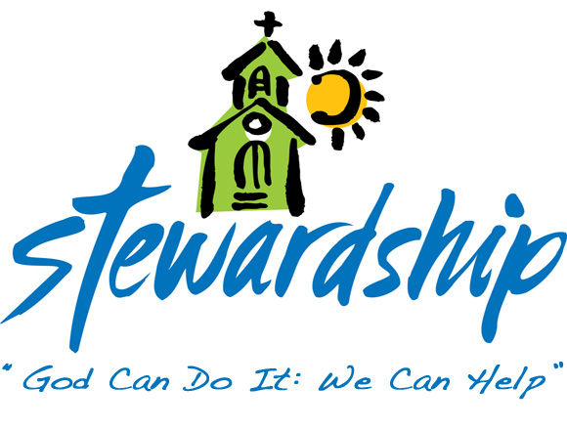
June 28, 2020
Church canceled
Offering – $695.00

July 5, 2020
Church canceled
Offering – $2,305.00

July 12, 2020
Church canceled
Offering – $715.00

July 19, 2020
Church canceled
Offering – $860.00

July 26, 2020
Church canceled
Offering – N/A

Commonwealth
United Methodist Church
2434 Commonwealth Ave.
Charlotte, NC 28205-5132
704-376-4924

July 28, 2020

Steve Kurt - Pastor
Patience Brumley - Pastoral Care

