Pastor’s Walk

For those of you who are Bill Murray fans, you are probably familiar with his movie “Ground Hog Day” where he wakes up to the same Ground Hog Day over and over again…over and over again….over and over again…until he gets it right.

I don’t know about you…but I am starting to feel like I am living that movie. Yes, everyday is a little different (for instance it is raining cats and dogs right now) but I am starting to seriously wonder…”How much longer?”

How much longer will we have to social distance? How much longer will my business be shut down? How much longer will we have to “stay-at-home”? How much longer will we need to wear masks to the store? How much longer will the store shelves be devoid of things like toilet paper and rice and cereal and so many other things? How much longer will the news only talk of the virus…the government’s response to the virus…the peoples response to the government’s response…the crazy theories…the challenges we are all facing? How much longer?

How much longer will public worship be suspended in our church?

And the answer is…much like Bill Murray’s character in “Ground Hog Day”…we do not know. I certainly do not know…and…I think no one knows, for sure. And it is “not knowing” that I am finding the most frustrating because, when it comes to my living my life, I like to know. I like to know or at the very least pretend like I know and have control over my life and the direction it is going.

Then I turn on my phone and I flip to the “Smart News” App and I see at the top of my screen the rolling infection rate and death rate for the United States. As I write this, almost 760,000 US citizens have been infected with COVID-19 and over 40,000 have died with four of those dying just today by 9:30 am….and the numbers just keep growing and people keep dying and….

Suddenly…I don’t want to know anything!

The truth is…life is precarious and unsure and precious and important and fragile and ours on this earth for only a short period of time. So the best thing we can often do is live it while we still have it and find ways to live it well! Live life with compassion…with truth…with grace…and with love!

This is why I believe I am called to be a follower of Jesus Christ. For when I read and study His teachings, I see in Him a way for me to live my life…here on earth…with all those things…with all that love and grace and compassion. Christ Jesus came…was crucified…died and was raised from that death just for that purpose…so that we would know true life!

So as we all go forward into this great unknown…as we struggle when to lift restrictions…what restrictions to keep…how we will be required to live in a post COVID 19 world…let us all hold on to not what we want for our life but the life Jesus Christ came to give us those many years ago. For in Jesus, this life is important and how we live this life matters but what matters most…the life that is most important is that life after life…that eternal life with the Father. So my friends, go into this unknown knowing that your life is no longer your own…your future is indeed certain…your goal is still the same…your sins have been forgiven….your gift has been paid for…your life has been made anew…all in the name of the Father and the Son and the Holy Spirit…Amen!

Grace,
Rev. Steve Kurt

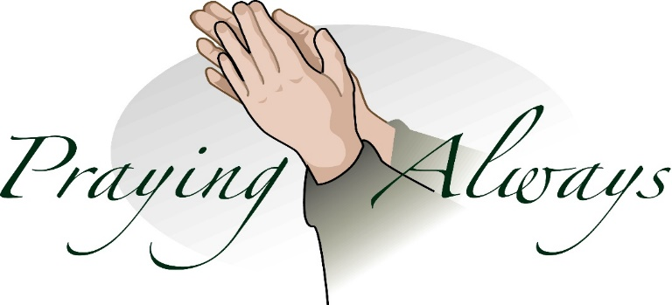

When Will We be Able to Worship Together Again????

I know this is the question that we are all asking ourselves these days…plus many, many more I am sure!

As many of you have probably already heard, Governor Cooper has extended his “stay-at-home” order to the 8th of May and then he will role out a loosening of restrictions in phases (if all goes well). This order effectively keeps us from legally gathering for worship until after that date. And it is looking like that even after the 8th, we will need to be patient and deliberate in how we reopen CUMC to public worship. It is not clear to me which phase will allow us to continue our regularly scheduled worship services. A lot will have to do with how effectively we can design our service to be both inviting and safe for all. Realistically, I am thinking we will be lucky if we can resume service before the 1st of June but I will not be surprised if it is not mid June or beyond.

In the coming weeks, as things become more clear and we are more certain as to how and when the restrictions will be lifted, I along with the Administrative Board will work on a plan for resumption of public worship. At this moment, things are just a little too unclear to effectively plan. However, I think you will all agree that there is, to be seen, a glimmer of light from the end of this long dark tunnel we have all been traversing this past month.

So my friends, stay tuned and stay hopeful and I am certain we will be calling on many of you to help with the reopening of worship at CUMC. There will be pews and door knobs to disinfect, gardens and bushes to attend to, and new ways of doing church to learn. Things will be different and it will take work and adjustment on our part…however, one thing will remain the same…God will still be God and it will be God’s Holy presence we will come together as one to worship….perhaps just sitting a little further from one another.

Grace,
Rev. Steve Kurt

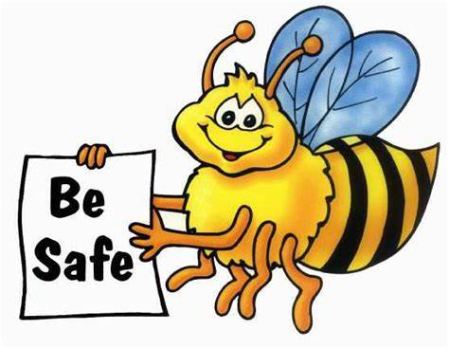

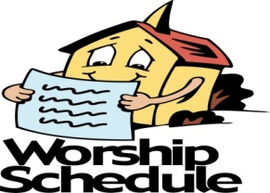

All Church activities have been postponed
until further notice

Administrative Council Meeting
Sunday April 26th has been canceled

May Birthdays

4 Janice Rose
11 Patience Brumley
14 Robert Kurt
15 Nadine Starnes
17 Hannah Beaver
22 John Beaver
25 Mackenzie Garlick

May 10th

Wesleyan Circle Meeting

May 11th has been CANCELED

Wednesday is Day of Prayer
Remember to pray for those in need.
Prayer box located in the Narthex

Our Prayer List

Jack Harwell (brother of Ruby Agnew), Alma Horne, Pat Inman (sister of Jackie Samuels), Maxine Kincaid, Rosemary Lands, Martha Lee,Jean Stoneman

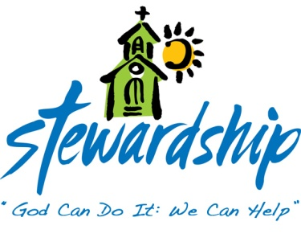
March 22, 2020
Church canceled
Due to COVID-19
Offering - $475.00

March 29, 2020
Church canceled
Due to COVID-19
Offering - $2,415.00

April 5, 2020
Church canceled
Due to COVID-19
Offering - $950.00

April 12, 2020
Church canceled
Due to COVID-19
Offering - $475.00

April 19, 2020
Church canceled
Due to COVID-19
Offering - n/a

Commonwealth
United Methodist Church

2434 Commonwealth Ave.
Charlotte, NC 28205-5132
704-376-4924

April 21, 2020

Steve Kurt- Pastor
Patience Brumley- Pastoral Care

Sunday School- 10:00am
Worship Service - 11:00am

Office Hours
Mon. - Thurs. 9am to 1pm

