Commonwealth United Methodist Church

January 2020
Sunday | Monday | Tuesday | Wednesday | Thursday | Friday | Saturday
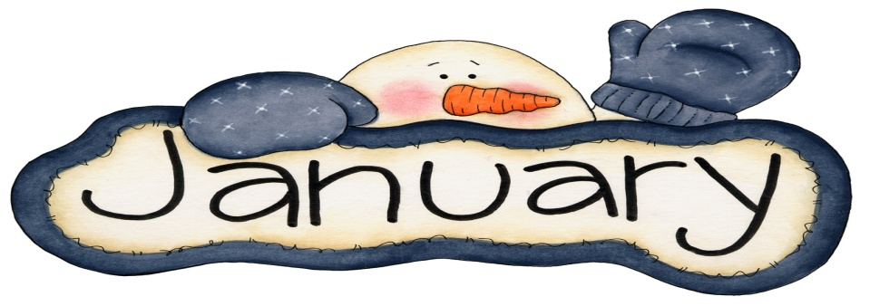 |  |  | 1 New Year’s Day  Church Office Closed  Day of Prayer  8pm AA Meeting (FH) | 2 | 3  Church Office Closed | 4  Fellowship Hall (reserved)
5  10am Sunday School  11am Worship  1-5pm IOCC (Lands Class)  Counters - Leigh Beaver | 6 | 7 | 8  Day of Prayer  8pm AA Meeting (FH) | 9  4-6pm Clothing Closet | 10  Church Office Closed | 11
12  10am Sunday School  11am Worship  1-5pm IOCC (Lands Class)  Counters - Perry Beaver and Jackie Samuels | 13 | 14  12:30pm Wesleyan Circle (Church Office) | 15  Day of Prayer  8pm AA Meeting (FH) | 16 | 17  Church Office Closed | 18
19  10am Sunday School  11am Worship  1-5pm IOCC (Lands Class)  Counters - John Beaver and Kay Little | 20 | 21  Newsletter Day | 22  Day of Prayer  8pm AA Meeting (FH) | 23 | 24  Church Office Closed | 25
26  10am Sunday School  11am Worship  12pm Administrative Council Meeting (FH)  1-5pm IOCC (Lands Class)  Counters - Phyllis Batts and Leigh Beaver | 27 | 28 | 29  Day of Prayer  8pm AA Meeting (FH) | 30 | 31  Church Office Closed
Choir Practice: Sunday’s at 9am in the Choir Room Greeters/Ushers: Billie Gardner and Trena Williams
Steward: John Beaver Bell Ringer: Grace/Hannah Beaver Acolyte: Robert Kurt

